Note: IF a hot link won’t open, you might need to press Control & click.

Eighty Days in the Snow

As inspiring to new beginnings as was this sunrise,
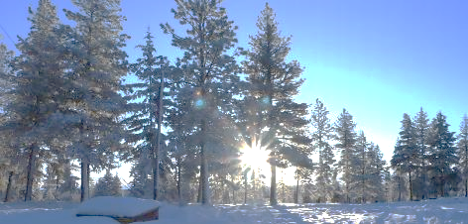
I dropped the ball in pre-winter preparations. I intended to be snowed-in atop the 5000 feet of mountain elevation I own in the USA’s Great Northwest by now. It’ an old, and now historic fire lookout, which sits atop mountain deep within a huge tree farm. This sequester could last up to five winter months. I have a plan, as this will be the fifth winter of sequestering on my isolated property. I love it. It’s quite a challenge. One must be fully prepared for anything, as I have no human neighbors to assist me in times of need. I have wild animals: deer, turkeys, squirrels, chipmunks, badgers, skunks, bobcats, cougars, bears, wolves, magpies, ravens, blue and grey jaybirds, and seasonal hawks and eagles. Will any of them help me if I find myself in need? No. But if I’m dead, the carnivores will assist in spreading my remains throughout the forest. I will become the forest. Nice.
I’d already been snowed-in if this were a heavy snow year. As it is, the snow depth on Jan. 5, 2025, is workable, but what lies beneath it is the problem. It’s fresh snow on slush, followed by a layer of snowpack and ice. The lack of traction is the problem. So much so that the tires on the three-quarter ton Ford snowplow truck, even with their V-bar chains biting hard into the thick snow-packed ice, tend to break traction and spin. The problem is the mountain road’s ten-degree angle.
Tomorrow, I must go into the valley to gather gasoline, water, and whatever else I can think of that I will need. Plow, I must. Downhill travel has its dangers, such as the inability to stop, or when the turned wheels slide off the road and straight into something instead of going around a curve. It’s the ascent that is the true worry. I will drive the snowplow to town to fill the two gas tanks, risking the chance of a ticket for the two miles of running tire chains on bare asphalt. After the elevation lowers, most of the travel will be dirt. If the drive home is successful, I’ll take the 1997 Dodge Tahoe to Enterprise, the county seat, which is fifty miles away. I will bite the bullet and buy some tire chains for it.
With luck, I will pick up the bottle of copper oxidizer I ordered online for the stamped copper buttons I’ll be producing.
“I’m plowing, I’m plowing.”
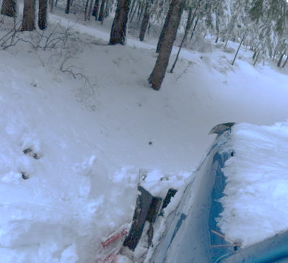
Occasionally, a whiff of smoke wafts through the truck’s cabin. I can’t help but wonder what’s burning. I know what…this and a dozen more smoldering slash piles from the recent logging operation.
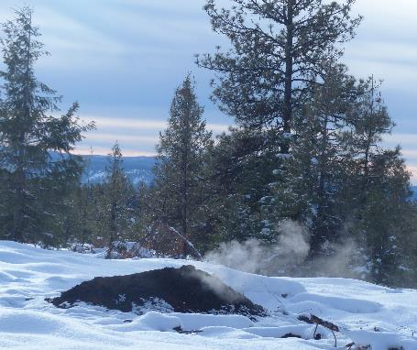
Bobcat in the neighborhood.
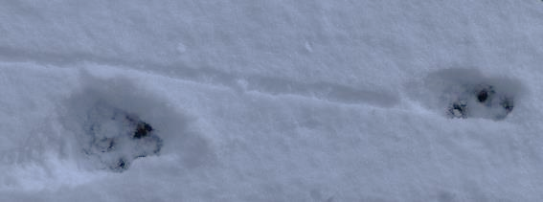
The water table is full.
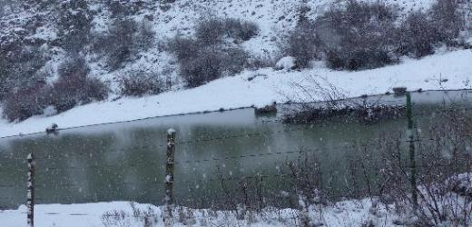
Herein lies the treachery of the drive. A tree and plant covered rock wall borders the left when driving uphill and a twelve-foot drop to the creek is on the right. Stay the course between them.
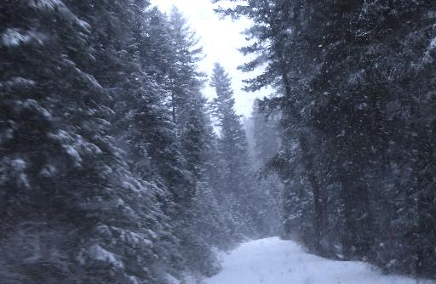
On the happy end of the danger-stick are these cheery beasts.
They have yard cohorts.
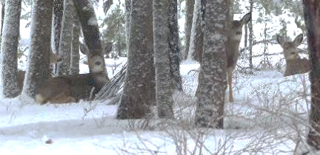

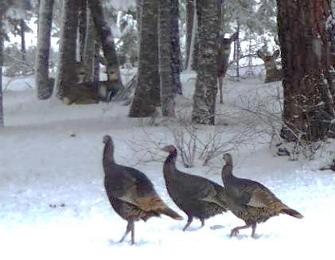
The current Moon’s second quarter has passed, and we are in the third one. A hazy sky makes for a blurry photo.
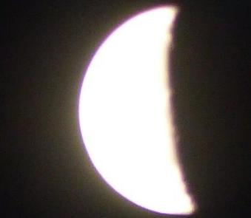
The following two photos depict a road that has been plowed often and wide. That’s the rule of snowplowing: Do it often and widely, and there will still be a place to put the newly fallen snow.
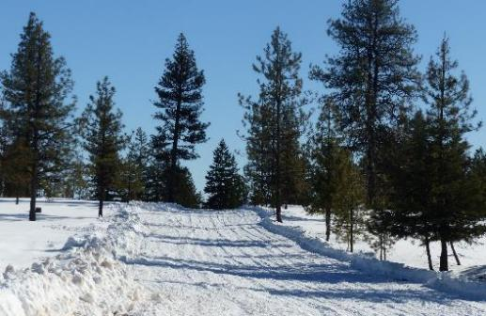
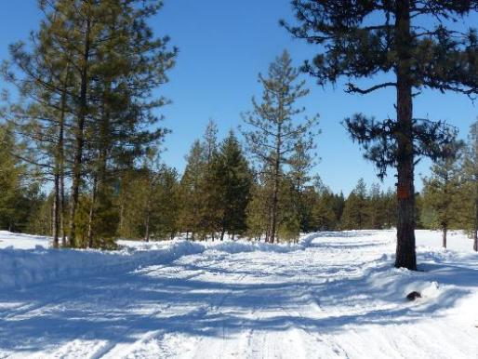

New Moon Cometh

Last night, I slept 10 hours without getting up to pee, which is nice. I wore myself out moving snow by plow, shovel, and snowblower. I don’t mind getting up to pee after 4+ hours of sleep if I can do a quick perimeter check and shoot a moon photo.
I woke up at six and went out to pee wearing only a T-shirt. As I stood there enjoying the dawn breaking, I realized that a jacket and some pants would be cozier. Once I was back inside the cabin, I looked at the outside thermometer. It was a nipply 5 degrees.
The real show was beginning as the wee crescent moon rose into the morning sky. The yellow of the one on the left is when it was still within the morning haze. The following photo was taken from my office chair through the door window. The reflection on the double-plate glass causes the ghostly second image.
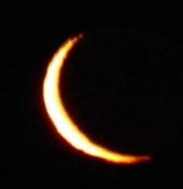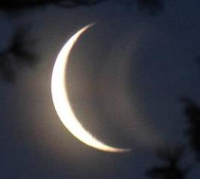
Finally, the last of the Old Moon rose into daylight.
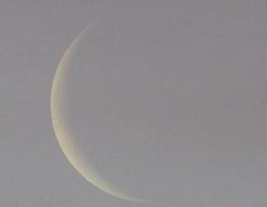
Are these the last shots of this waning moon, or could there be a thinner one tomorrow?
I set up the metal press to begin the button-making process, a winter art/craft project. I focused on and completed 26 stamped copper rounds for buttons. One of the tricks of a sequester is to have a purpose and keep busy. The satisfaction of completing these tasks fuels my motivation to continue working on such products to share in the spring.

The Button Project

Lenticular clouds are my favorite.
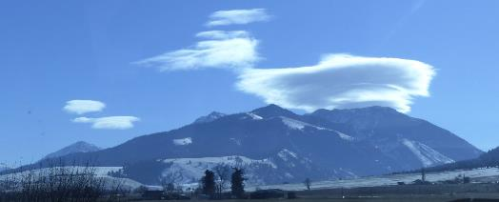
I have two outbuildings used as workshops, but the heat is minimal, and they have no insulation. The warm cabin is so much more conducive to this handmade labor. At my location, the winter temperatures can fall to subzero.
I have the button-production work bench set up in the cabin. All the tools, save the press, are on the workbench and ready for use.
Note the jar of smokeable herbs. Yes, that will make it fun.
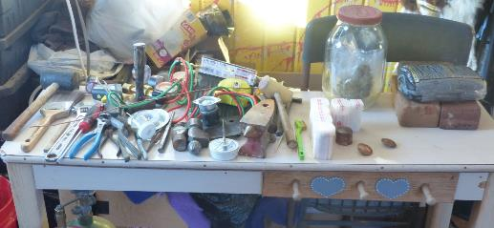
I brought in a log cut to size to give the press stability and solidity.
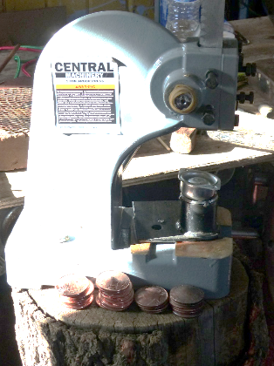
Much to my dismay, I had to make an unscheduled run to the hardware store to buy more lead-free solder and copper shank wire. As with handguns, it’s better to have what you need when you need it than not to have it.
The doming of button rounds needs a dap and a dapping block. Using the leveraged power of the press to push the dap and copper round into the recess of the block, a dome is made.
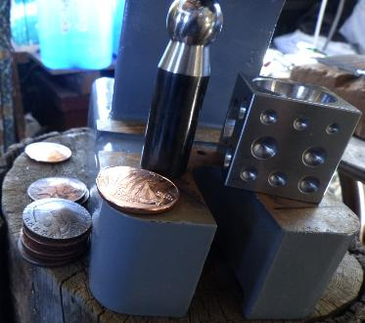
Each doming takes thirty seconds. I can do 2 per minute or 120 per hour if I want a job. NAH! I want to have some fun making arts and crafts. Twenty-nine is a start, and I have 100 more if I care to make that many. Without an established market, that could be a wasteful mistake. This was the beginning of the test run. Tomorrow’s test will be loop-making and soldering.
Domed buttons need loops as fasteners. The first step is to anneal the copper wire to make it soft and pliable so it can be bent into a round loop and then soldered onto the back of the domed button.
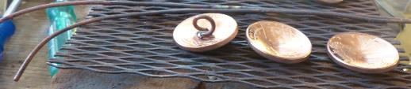
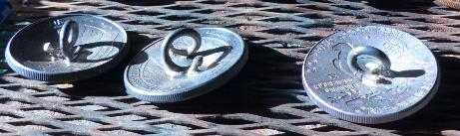
I wonder if Flasher needs a copper button to go with his golden winter shine?
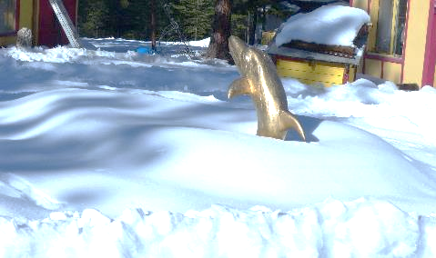
I had to do another run into the valley. Will it ever end? No.
I haven’t had any deer friends visiting of late. Why? Because they are down the hill, languishing in the fields of the dried grasses.
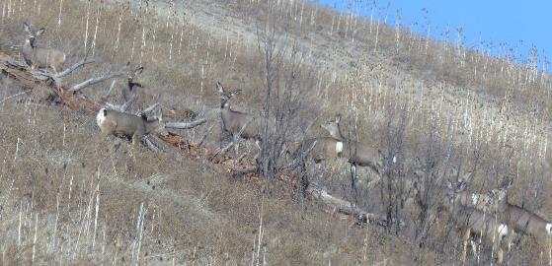
Will I find a dead carcass in this pond come summertime? See the hole. Bobcat-sized, I reckon. Maybe a shotgun puncture. I would love a bobcat skull to clean up and place on a shelf, as I did to this badger’s skull.
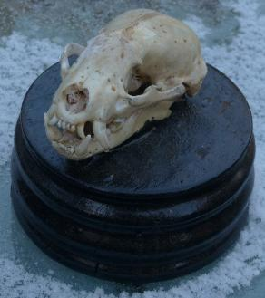
I’d like to say this badger volunteered its head to join the others in my skull collection, but it didn’t.

I shot it as it scurried about digging holes in my yard as it hunted for Red Digger dens to pilfer. The holes are best described as ankle-breakers. The hide now hangs on my wall.
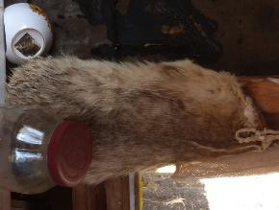
This is a coyote skull that I used as the armature for this dragon head. It was not voluntarily given. The poor bugger got caught in the state animal control trap to reduce the pack to help the sheep herder from losing too many kills. I would have preferred a wolf skull. They get trapped, too, but most get killed by a State paid gunner.
I woke up with the need for a skull. My Gawd provides good stuff right on time. I drove into the forest and not two miles away was the trapped coyote.
I got out of my truck, with a 9mm pistol in hand, had a quieting conversation with the beast. I thanked it for the contribution to this project. I then shot it in its right eye. There is a lot of skull bones behind an eye socket. Yes, the coyote tipped over, but the rule is, do not rush up to a recently shot predator. It might not be dead, just knock unconscious. This was the case with the coyote. It snapped awake and jumped back up onto its three good legs. The bad foot was still caught in the jaws of the trap.
I put three bullets in its midsection, behind the shoulder blade. It dropped again and stayed dropped.
I lopped off its head with a machete and took it home.
The flesh and brain cleaning process starts with boiling of a light amount of bleach and water. The softened meat, brain, and hide can then be easily scraped out and pulled off after the boil.
Let it dry and then rub it free of leftover organics with something abrasive like a knife or wire brush. Next, soak it in a fifty-fifty solution of hydrogen peroxide and water. The bones will be nice and white the next day.
I used paste epoxy for the remake of its coat, and tin for its eyes and horns. I used a high speed Fordom Flex Shaft grinder and carbon tip cutter to put the pattern on the surface of the wood.
Bingo! It’s a new art piece for the gallery.
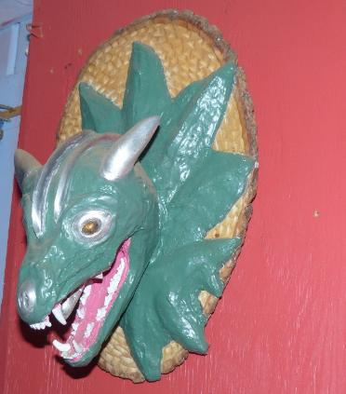
I found a bear’s carcass on the road and brought it home.
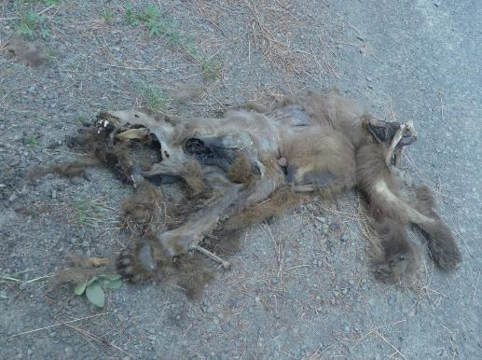
I have its skull in the process of cleanup. It was roadkill and not intact.
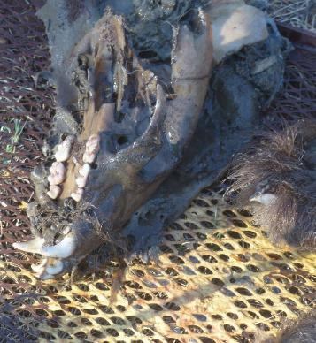
I’ll use the teeth and claws for a necklace or two.
I have its claws, too.
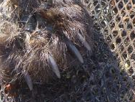
I need to find a place for this piece of smokeship history.
Maybe the WAMM Museum in Hood River. I’d make it a promo for the Smithsonian display of the entire apparatus.
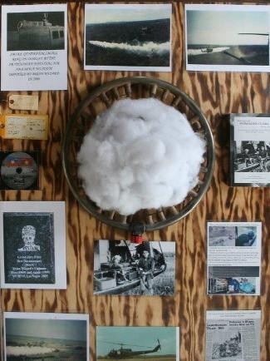
I could have shot this young bear, but it was too young. It needed to experience more life. You can experience the conversation we had after it climbed a tree.
https://bwizard.art/bw_videos/the-bear-facts/
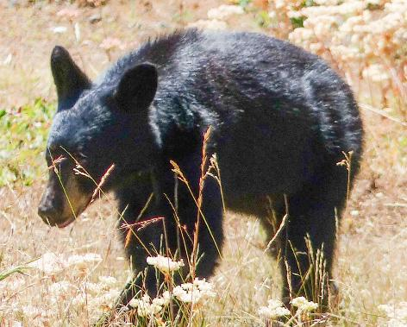
I talk and sing or play music with all the other small beasts. Under the Video link on the top of the home page. Here’s a few:
https://bwizard.art/bw_videos/gog-wobblin/
https://bwizard.art/bw_videos/good-morning-song/
https://bwizard.art/bw_videos/hear-us-sing/
This is my most famous photo. Me in the door of Pollution IV.
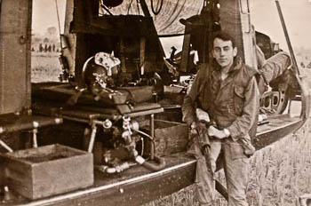
At this time in 2005, when dedicating my combat gear to the Smithsonian Air and Space Museum, I was loaded for sweet young groupies who would sing their songs of pleasure to the world.
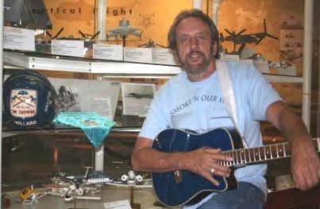
And I would dream on.
Eighteen months after my graduation photo,
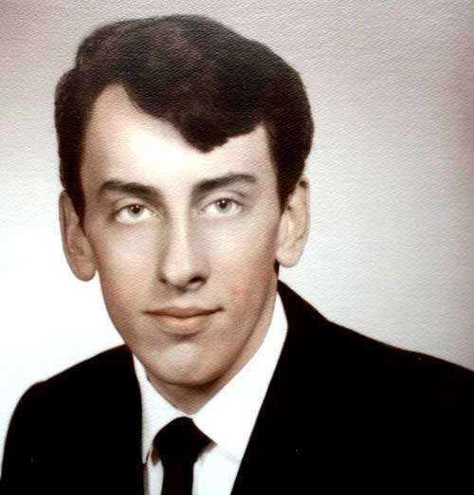
I was photographed stealing enemy flags from their strongholds when standing on a Pollution IV skid.
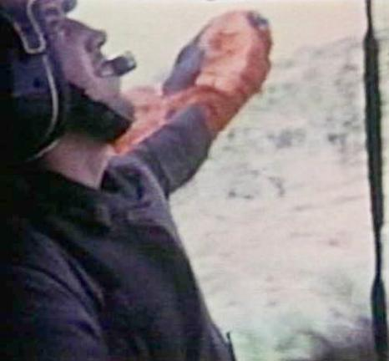
There’s me on the left and the crew I flew with unwinding from a hard and dangerous day at the office.
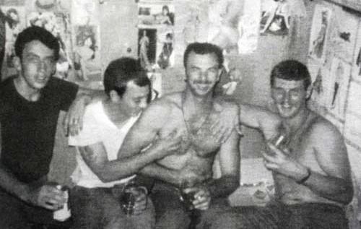
On the far right is Harvey, my combat mentor, holding a glass of Jack Daniels, with Larry squeezing one of Doug’s hard chest muscles. They both came from an artillery unit on the DMZ.
The Playboy centerfolds posted on the walls were all the reason we needed to fight. Fight, win, stay alive and get some of that goodness.
Earlier that day, we were being shot at by enemy that were hole-up in a bunker within the tree line. That smoke in the tree line came from exploding rockets launched from a gunship to kill and dissuade the enemy from shooting at the passing flight.
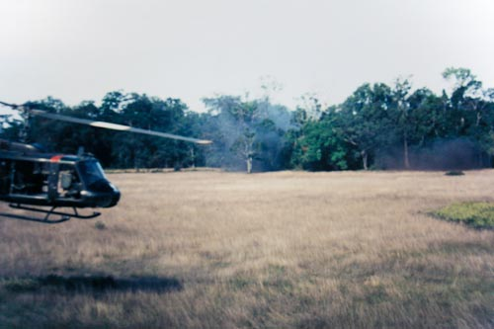
The dark color on the deck comes from coffee grounds, which provide boot traction and helps with ice melting.
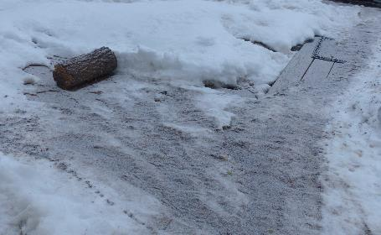
Morning brought back the snow and the deer.
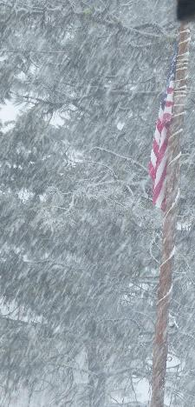
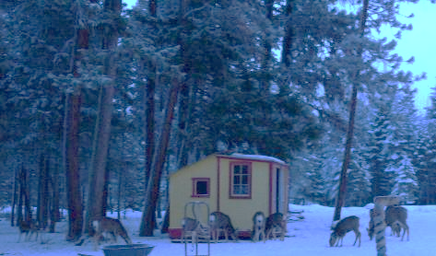
Here they is the first finished run of 29 stamped copper buttons.
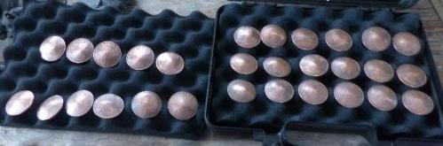
The following experiment was to darken the stamped recess around the elevated design using a felt-tip pen.
These are not yet in the finished stage.
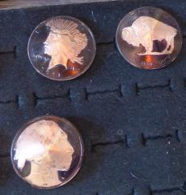
This pistol case may become my portable button display case.
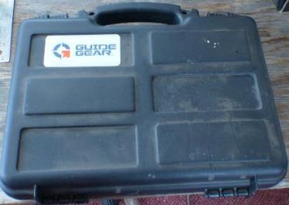
There is a process for finishing the buttons. After the scorching heat of soldering, you can see a residue of fire scale. Any impurities rise to the surface when heated, and the wire brush easily removes the scale. It’s the impurities that make the rounds only .9999% copper.
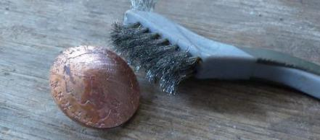 Not good
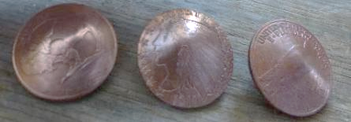 Much better.
Here’s proof that I am as cute as a button. The Injun has nothing over me. I am halfway through my 76th year and look as old, tattered, wrinkled, and fun as I should. It could be worse. Look in the mirror. (Joking)
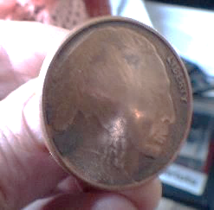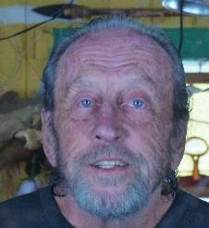
This has been a productive first quarter. Venus joined the New Moon to celebrate my good work, and it’s good to hear the audience applause.
Oh, there is no sound in the vacuum of space. This is why we a blessed with vivid imaginations.

I was making buttons like I did back in the 1970s. At that time, I influenced the leather fashion industry up and down the West Coast. Now that I’ve made more, I realize I don’t want to make buttons. The market is thin and narrow due to the influx of zipper-inclusive Chinese made leather fashions.
I’ve made yet another business to sell to someone who wants to develop a cottage craft industry. The same is true of my Sterling Silver Jesus rings. They are the best Jesus rings ever made. Just ask me, and I’ll tell you it’s true. Smooth, comfortable, and fun.
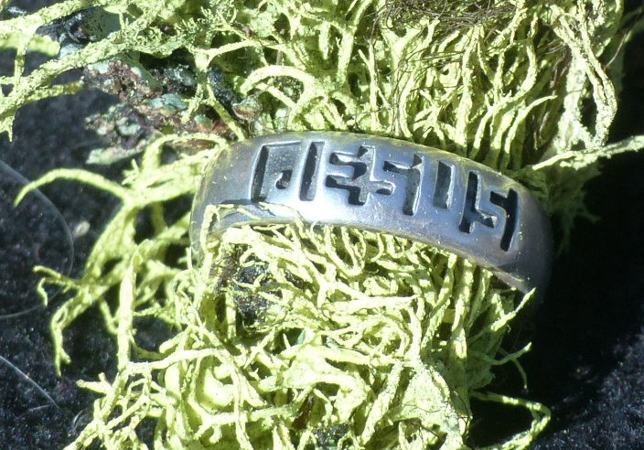
I don’t offer them on my new website. It turns out Christians prefer to celebrate an execution device to wear on a chain around their necks instead of the name of their Savior. Odd, I reckon. They don’t say, “In the name of the cross…” No. They say, “In the name of Jesus.”
But, if you really want one, contact me:
https://bwizard.art/contact-us/
I need an audience with the Pope. After I give him ring, he can hold up his hand and show it to the masses during Masses. A magnanimous Christian could buy one for every Nun, since they marry the idea of Jesus. Maybe I could get the Pope to bless the rings en masse. I could then promote them with “Blessed by the Pope.”
What will come next? The writing of my fight with the VA, which has exchanged my reputation as a war hero for that of a criminal? That’s nothing short of a defamation of my extremely patriotic character. I’ll be filing a 30-million-dollar defamation lawsuit.
I was charged, tried, convicted, and sentenced to a two-year ban from VA medical services at all VA hospitals and clinics nationwide. Why? A woke liberal pussy sent in an anonymous complaint that I threatened and disrupted something, somewhere, somehow, at some time. I have no details as I was not invited to the closed-door Staci Police kangaroo court hearing regarding this charge. Even after deciding to ban me, I was never told what, when, or where this “crime” occurred. This is to say that the VA’s idea of justice is to proclaim me guilty until proven innocent, but without any say in the argument, no evidence to rebuke, or a chance to defend myself. What country do they work in? Who do they serve? A serious comeuppance is due.
This is the disrespect they show toward older veterans of war. “Kick out the oldies, and they will die.” This sounds like the work of the Architects of the Viet Nam War. They are doing it to anyone, for reason or not.
They claim that this is what they must do to protect the staff members from threats, abuse, harassment, and even rape by the veterans they serve. Excuse me, punks, but I’m a real man who likes having sex with real women, and there are three ways of procuring said sex: charm, payment, or rape. I’ve never raped anyone, but I have had consensual sex with three female VA staff members—no complaints from any of them. I also learned long ago that threats hold neither weight, water, nor truth.
Threats are only words. It’s the actions that count. Watch my Viet Nam documentary, Viet Nam: Then, Again, and Beyond. It’s on my website, bwizard.art, for FREE.
Visit: https://bwizard.art/#then_again_and_beyond
It’s not the medley of songs in the video. It’s the 66-minute doco of pure BW combat forethought and genius.
You’ll see how I never threatened anyone. I tracked them down by machinegun fire and killed them.
Then it is known that VA staff members tend to provoke veterans with their stupidity, incompetence, and rude, woke, and queer agendas. During my mandatory annual checkup, a morbidly obese nurse asked me if I was sexually active and what my preference was. “Young, wet, tight, beautiful, intelligent, and free of all STDs.” That’s what I should have told her. Her morbid obesity disqualified her, so she was safe.
This was not a VA clinic, per se. It was a temporary place for the new VA medical clinic but being conducted by a non-VA facility. The VA offered to pay for the appointment After they insulted and abused me, I told the VA not to pay this bill.
The building’s real purpose was that of a birthing clinic. I was in a room with a double bed, so I suggested the short, fat, woke-joke put $100 on the table and meet me on the bed. I would then show her my ‘preference’. She’s so fat that I doubt she’s ever had sex or seen where it goes.
Fact: My sex life is none of her business, and her asking provoked me. She was flaunting her woke and queer indoctrinations with me as a target. Would it lead to her asking me if I wanted a sex change? Of course, my reply to her out-of-line question was said as comic relief. I’m sure it was the best offer she had had for a while, and she took it too seriously. That’s what comes with AVS: Angry Vagina Syndrome.
I know, I just pissed off a handful of my readers. Queer and woke are the latest rebellions against “normal.” I won’t support this idiocy, even if they say they cannot control it. The number one rule of all things in this material world is: Structure Governs Function. In the world of construction, it is THE rule to follow. Otherwise, the structure will collapse. Just ask Trump.
I do not care what anyone does for sexual release. It’s pushing queerness on children and heterosexual adults that rubs me the wrong way. So, if my words rub you wrong, oh well, this is my novella, and now you know how I feel about the “woke-joke” and the queer indoctrination of the young and vulnerable. We have the First Amendment of Free Speech. She initiated the topic, and I finished it. She got up and left in a huff. That was funny. I offered to apologize to her, but the doctor/PA said it was “Too late for that.” It was a typical woke-shutdown to an easy correction. Those who can’t accept an apology prove themselves to be in error. It’s called diplomacy. The woke crowd lacks understanding and pretends to dominate their arguments with unjustified ridicule, anger, hate, and if possible, retribution. What can be done? Mostly, they are young, dumb, and lack a sense of fun. It is easier to criticize someone than to let them be themselves. I don’t believe the woke and queer agendas are logical thinking, but I’m not going to beat them down for their thoughts, unless they stuff it in my face as if that's the truth, or in a professional setting. Not without pushbacks.
I have some queer friends. All is good when sitting on a couch or in a vehicle side by side, if they don’t rub my thigh, try to hold my hand, or look at me with lust-filled bedroom eyes. Also, I don’t want to see the biological men dressed up as if they were female.
The guy at one of the local gas stations comes out to pump gas in a pink dress, earrings, and makeup. I always ask, “Is it Halloween?”
While in the valley, I washed the Dodge. The mud on the sides was an eighth-inch thick, but what the heck—how could it hurt? When driving on dirt roads, mud spray and splatter are the norm. Washing a vehicle subjected to such conditions is an exercise of futility.
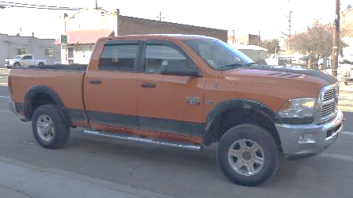
Outside work involves chopping and removing ice and packed snow around the cabin’s steps. My walkway is pure snowpack. The good news is that my slippers have great gripping power on snow. Soft rubber soles give them the advantage of traction.
These are the two major paths I walk through the winter snow.
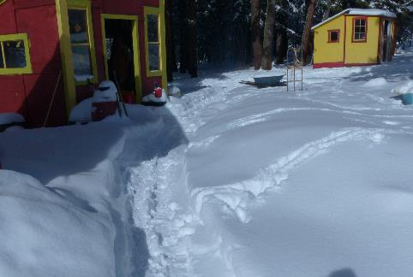
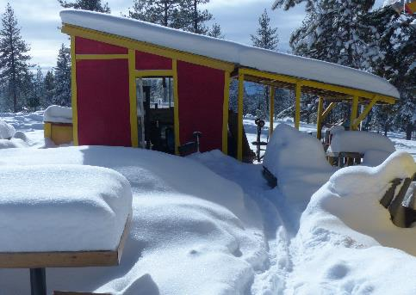
I bought a snowblower but struggled to get it to work well. That’s because the people I bought it from never explained some of the details of what makes it work. I found how to overcome the shortcomings.
After I hear that a significant storm or several small storms will bring 8+ inches of snow, I will plow the main logging road down to the corrals, which is a six-mile drive, twelve-miles including a return trip, and twenty-four if I plow it twice to make it wide. This will prevent me from being snowed in.
Being a forward-thinker, I might want to step out in March to use timeshare points before I lose them. This will only cost me money, and this time of year is when I can save the most amount of money. The sequester is the game plan, and I should stick to it, not go wandering about.
Where to go would be the big question. I’m considering staying close to home or going to Nashville to register a handful of new songs with ASCAP. I like the royalty checks I occasionally receive. A sequester is a way to save money. I don’t want to spend much money this winter, so staying close to home will probably work best.
Okay, the New Moon is about to happen. What incredible fun will it bring me?

Setting Up the Game Plan.

Before any game is played fairly, all players must know the goals and rules. I’ll set both right now from my point of view:
- Track the developments throughout this sequester and self-help game in this diary.
- Make it all fun.
- Go deep and reward myself with revelations on becoming a better me in the future.
- How to act in public. That’s a hard one. People today are not fun, lack a sense of humor, don’t understand a gregarious personality, are shallow in thoughts and deeds, and are quick to condemn, judge, and negatively respond to any action not generated by their twisted indoctrinations. I buck most indoctrinations the other people let mold their lives.
- Focus on button production, music, and snow manipulations.
- Survive.
This is the third day of this game. The good news is that the turkeys have not abandoned me. As usual, they have assigned one turkey to keep an eye on me. I like that. “Never leave a man behind” appears to be their philosophy. They will all return soon enough.
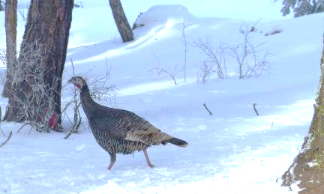
This will save me money on feed and give me a living being to say, “Good morning, Ms. Bird.”
Today, I only had five out of fifteen deer join Ms. Bird and me for breakfast.
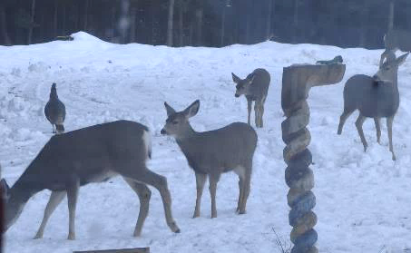
I’ve taken more photos of snow-covered trees for possible use in the shower curtain idea. I don’t know how wide such curtains are. Research is due. Would sitting on the loo and staring at such a curtain be relaxing and get things moving for those that might like to buy one? Or do they prefer stained tiled walls?
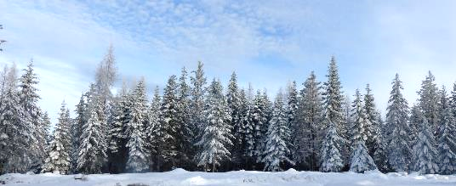
The big astronomical show tonight is one I have photographed before. Mars will slip behind the Full Moon from a low position and reappear higher on the other side. A clear sky and paying attention are key ingredients for this successful photoshoot. It will keep my mind focused on something other than…?
The morning’s twenty-three-degree air outside did not attract my attention. Here’s another discipline I need to keep up with, mice killing(s).
Soon after the autumn skunk left, the mouse population increased. I’ve killed 12 mice so far by trap this year. Last night, I set the traps in the kitchen, in front of the refrigerator
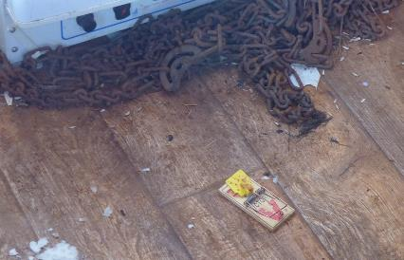
When I went to do the body count this morning, I only found one trap. The other was stolen by… a mouse or the pine-boomer squirrel, which had only a body part trapped and ran away with the device.
I set three more traps in the Dodge last night. I’ve looked several times today, and neither was hit. I could already be winning.
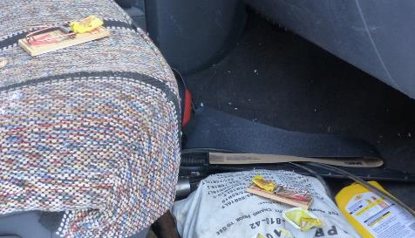
One more discipline to follow is music playing. I have three guitars, three ukuleles, a trumpet and bugle, four concert flutes, six bamboo flutes, a Brian Wizard Humming Blade, and a set of six chimes incorporated into the spine of an Arizona desert cattle, which I call a Bona-chime.
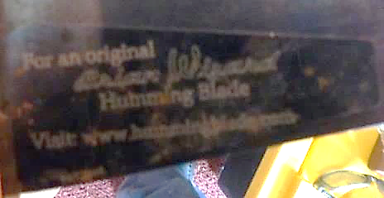
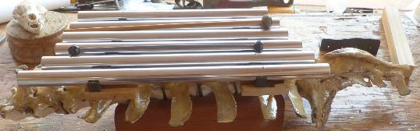
I play both on bwizard.art in the Video section.
Will music be made? If not, I promise there will be noise.
I will set things up by tuning all the string instruments one at a time. I don’t want any string to be tight if it suddenly gets caught in the frigid air as the metal condenses, ripping away the glued-on bridge from the instrument’s body.
After practicing music for over 56 years, playing and singing, I believe I have reached the pinnacle of my music career with the four illustrated music videos that are part of the Life Immaculate Trilogy. If I do more, and they are not as good, my music presentations will digress. All four are on the front page of bwizard.art in the Life Immaculate section: Buried in the Dirt of Boot Hill, the Seagull Song, What About Me? and On the Prowl. All written and performed by yours truly, with artwork by RRC in Venezuela.
Another measurement will be tracking the snow depth. This is a late January reading.
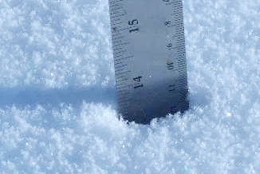
One discipline I always struggle to master is repetitive exercise workouts for health and strength. It simply is not in my genes. What I prefer doing is physical labor as a workout. Working the chainsaw, shovel, snowblower, and other tools is a full-body workout. I like seeing products and progress. We’ll see how that goes. My last heavy task was moving 1500 pounds of 40-pound bags of grain and seeds by hand. This act made my lower back hurt for five days. I hate having pain from doing such work: pain, no gain.
Do you see the patterns developing? I set something up to happen, and it either will or will not. If I make either fun, I win.
Note: Did you notice that I could not capture the New Moon in a photo? Clouds will do that.
Of course, anything celestial needs a clear sky. The Mars/Moon show remained behind the curtain of clouds initially. Too close to the horizon’s haze.
Soon after the Full Moon rose, it looked like this:

My hopes for a clear sky waned quicker than the Moon.
Not long after, my hopes were sky-high again.

The show went somewhat hippie on me as time passed, with the pastel foreshadowing clouds.
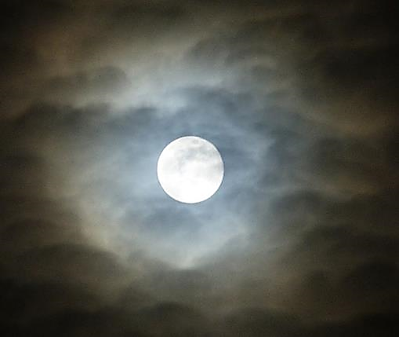
The show fell into a cloud tunnel, and I thought soon all would be lost.
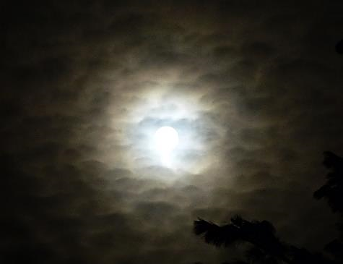
In the end, it wasn’t all bad. There was a moment of perfection. I didn’t see it develop. All we missed was Mars moving from one side, behind the Moon, and then out the other side. Nonetheless, there we have it, with Mars at 12:30-high.
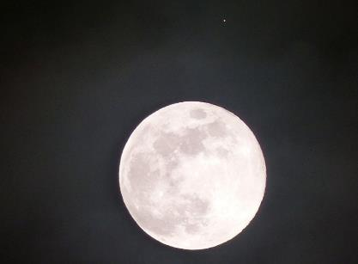
Let’s call it the Red Planet.
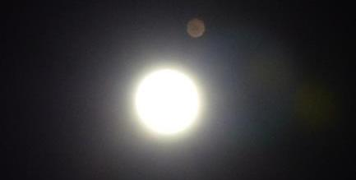

LIST OF THE DISCIPLINES

All projects need a To-Do List so that nothing is forgotten or left out. Errors like this lead to double-handling, and I hate double-handling.
As you read in the previous outline, the winter To-Do List is coming together. Let us review.

Copper Button Production

The two tumblers arrived, and I delivered the small one to my friend, Doug. He wants it for polishing ammo brass.
Next Tuesday, I will receive a larger tumbler for button polishing. The bottle of Liver of Sulfur has also arrived. The supplies for this project have come together.

Writing Projects

The fight against the VA's tyrannical, unconstitutional, Staci-commie justice system that allows anonymous reports singling out a veteran as hostile and disruptive has been delayed until Trump became President. I feel that Dems are anti-veteran, liars, cheats, and bullies. They run a “Guilty Without a Chance for Defense” judicial system within the VA. A veteran is charged, tried, convicted, and punished behind closed-door hearings, without the veteran’s knowledge or chance to defend against the anonymous charges. The veteran has only one chance to appeal the decision after it is in place, with no details of the alleged crime. One appeal only. The punishment is the banning of the veteran from all VA hospitals and clinics for two years, with Red Commie Flags stamped on the veteran’s files. These detrimental flags on the veteran’s records go nationwide. They are a warning to all VA staff members that this veteran has an “unproven history” of being violent and disruptive.
That is a Hell of a way to treat veterans, especially the old and vulnerable. We all signed the same government contract for the best medical care during and after our service. They have breached that contract and besmirched all veterans whose records carry these despicable Red Commie Flags.
This is what they did to me without me doing anything wrong. As I mentioned, the new breed of ‘woke’ people have no sense of humor and do not allow free speech. I intend to challenge this commie crap with a lawsuit for defamation of my award-winning military and post-military history, turning me from a hero into a suspected criminal of sexual harassment and even rape.
Their point is to protect the poor, innocent, and unable-to-defend-themselves staff members from the madmen/women, whom they are paid to serve. All are trained killers.
The bottom line in the first part is that one person’s concept of sexual harassment is another person’s concept of courtship. Rape, well, that’s just wrong. What fun would it be, anyhow? I want the gals’ joys and pleasures to be felt and heard, not their screams, fighting spirit, cries for help, and lack of honest participation. Add to that the fact that I’ve never harassed any VA staff member for sex. I never had to. I’ve had sex with three VA staff members (All consensual, if not their idea). All women are looking for love, sex, and a man's attention. Even lesbians, from what I’ve experienced. It’s the new-age young and easily controlled staff members that are sexually confused by the recent anti-heterosexual agendas that are a part of the queer-nation indoctrination and woke agendas taught in schools. I feel it is my warrior reputation and history that the VA has raped.
Another creative project is T-shirts that read:

Toxic Male.
Proud of it.
Military Trained.
Combat Hardened.
I’m here to help.

We’ll see how well my upcoming report goes with the VA and veterans-at-large. I think a 30-million-dollar defamation lawsuit should attract their attention. The more significant part is to quell the communist/Nazi takeover of the VA by the ‘woke’ jokes running the administration. This kangaroo justice is unacceptable to a man who has been an anti-communist since 1957 when the then-Russian dictator was on my parent’s black and white TV, pounding a podium and declaring he would bury us under nuclear rubble.
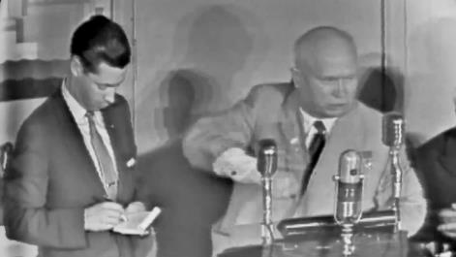
A second writing project will be four novellas that depict my daily life through the seasons. The set of four will be presented as eBooks on my website.
A novella typically has a word count between 17,500 and 40,000 words. This places it in length between a short story and a novel.

MUSIC

I have many instruments to play and record new stuff whenever I want. I will admit this: I’m torn between doing more and doing less, maybe to the point of quitting all music playing. I’m sure there is a compromise available. Having not played much of anything for a while, I can admit that I like the release from the nagging need to play.
Here's a compromise: I play mainly alone and by myself. I ask, “Why must I play an instrument to play the song in my head?” I hum very well, and whistle too. I can beat out a drum solo on just about anything. All the fine details of playing an instrument are nothing short of work. Sure, once I have memorized the lyrics of a song and the music is played, I can make a song to share. But if I am not going to share, why make the song beyond the call of duty, which is just a bit of fun?
I don’t hear much praise for my musical creations. Praise doesn’t pay the bills, either. If I’m not gaining praise or money, why put out the effort? Just whistle the days away, into the night, and continue to dream.

Snow Manipulations

So far, I’ve had two serious snow mishaps. The first happened when backing up the snowplow to turn around on the narrow road. It got stuck when the trailer hitch stinger hit a boulder and the flatbed slid up onto it.
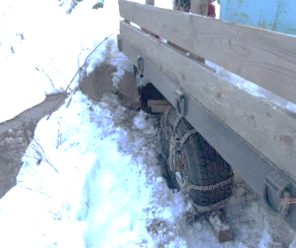
I tried every trick in the book to lift the trailer hitch off the rock it was caught on. The chained-up tires no longer touched the ground. The biggest trick was not to walk too close to the creek. There was no promise that the embankment wouldn’t collapse, tossing me into the cold drink.
I stuffed all sorts of things under the tires or close to them. None worked as planned.
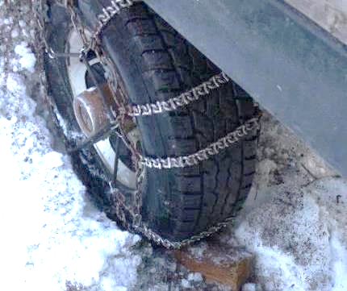
After hours of pure winter survival fun, I finally had to disconnect the winch from the plow to use the cable to pull the truck forward.
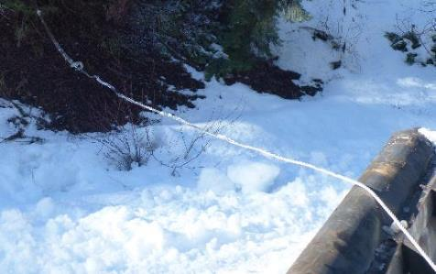

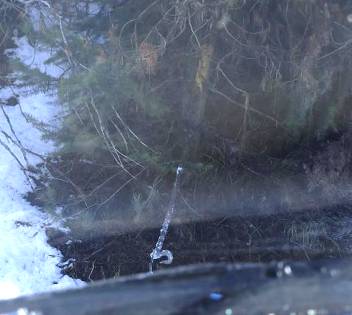
It worked, and nothing broke, like the cable, winch, or a universal joint in the driveline.
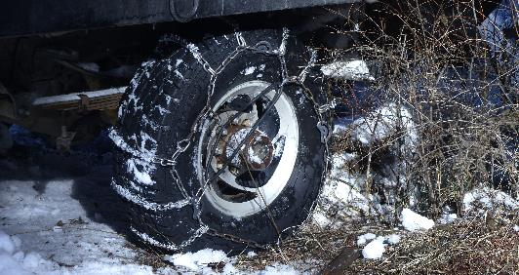
I was freed from the clutches of winter.
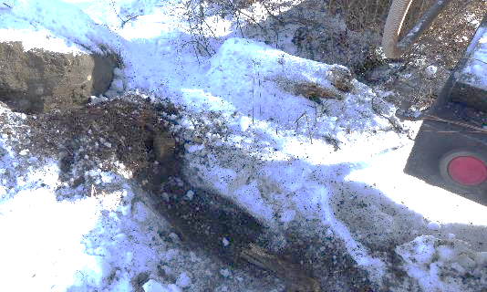
I won that game, which is always a good thing.
A week later, this happened:
I looked out my window, and what did I see? Clear weather. It's the perfect opportunity to plow the yard and driveway snow to the sides. I want to be prepared for the big snowstorms that dump 18-24 inches overnight.
You know the rule with plowing: Wide and often. This provides a place to put new snow. Otherwise, the sides close in, and plowing requires a different technique—back and forth at angles to make a path. With all the reverse truck movement, a mile-long snowplow detail can be twice or more than that.
I enjoy my rides through the forest, across the ridge, and downhill to whatever sights and sounds await. This includes a quick look at the winter beauty of the Seven Devils.
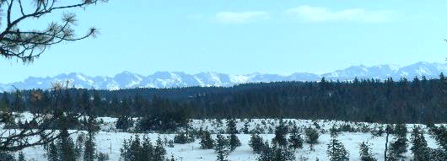
I know; I’m a man of habits.
Everything was going well until I approached the last water bar while going downhill. There is a place where I like to push the snow off the road and out of the way. The plow hit its mark, but maybe a tad too fast. The extra force forward made the recently silicone-sprayed blade slide out of my control down the slickery elevated road bank, taking the truck with it. I didn’t see it coming, but under the snow cover was a broken-off treetop. The truck’s left front tire hit the broken end just right to push the tire off the rim with a powerful burst of 50 pounds of air.
I knew my day had just changed.
First, a rumble and a grumble reverberated inside my intestinal tract. I had moments to prepare to purge the developing horror. I grabbed a piece of non-absorbent cloth from the floor of the cab, walked into the forest, dropped trou as I bent over, and let nature, gravity do what it must, and, like the tire, a blast of gas and debris spewed forth. I thought I was lucky to have the cloth for a thorough wipe. I didn’t want to sit in the snow for a cold wash.
Back to the truck tire. Did I have a spare tire at hand? Was it operational? Did I have the tools to remove it from its berth beneath the flatbed? I drove the truck to Whiskey Creek Road to turn around, then uphill and around the corner so the truck would not be seen from the road.
I parked on the uphill side of the water bar dip, which was flat, and then got out for an inspection.
The tire was not a pretty sight. It was airless, and the rubber was about to come off the rim. This is okay if it comes off on the outside, but not the inside. If it flapped around on the inside of the rim, it could take out a brake line.
Who knew that dead treetop was there? It was debris left from the summer logging operation.
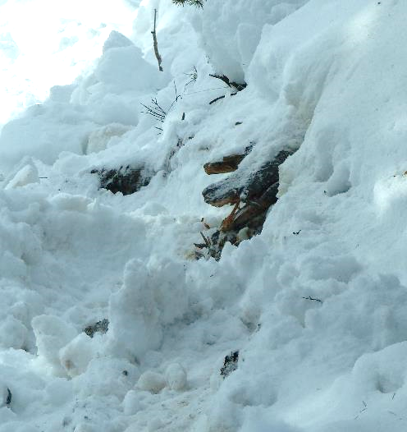
I wanted to change the tire in my yard, not on this road. I gave it a shot, but the no-air tire didn't provide enough traction to push the truck up the hill.
Driving backward around a corner with that worthless tire didn’t work well, either. Soon enough, the right rear tire found itself stuck in place.
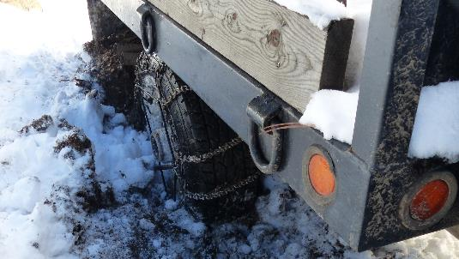
There was no tree to hook the winch to this time. I was back to the trick of stuffing anything I could under the tire. I made some progress, and with my best stuck-in-the-snow driving skills, I drove the truck forward and back downhill to the uphill dip of the water bar.
This is not the sight I was looking for, but the one I found.
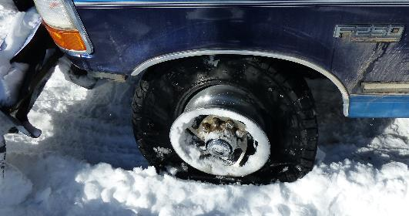
I needed to walk home and gather some tools and the Dodge. Mostly, I needed the floor jack, shovel, and pick.
You get this when you live on a slant: the ten-degree of slant.
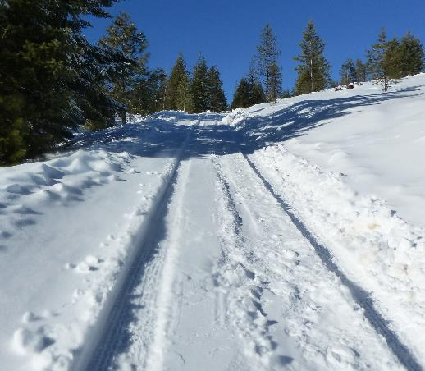
I only stopped once to rest. The following day, my legs could feel every step—proof that I’m not 42 anymore.
I loaded the truck with the tools I wanted and drove back to the scene of the mean snow area.
Here’s a chunk of ice that lies beneath the snow cover that broke away due to the contact sport of snowplowing.
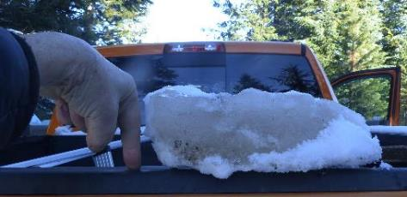
I hauled the floor jack down on a sled hooked to the trailer hitch.
I placed the jack on a flat piece of particle board, which kept it from being crushed into the snow.
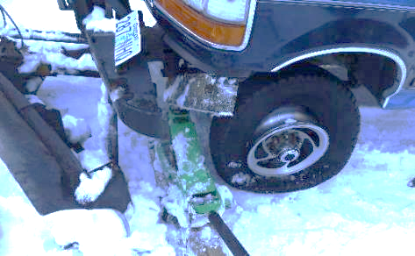
Before I removed the flat tire, I needed to extract the spare. I studied the situation and tried various angles and tools for the attack, but it wasn’t coming down. The lip of the flatbed covered the hole to stick the cranking bar into, which would lower the spare to the ground. No cranking, no lowering.
The sun was going down, darkness was coming quickly enough, and I still had to get up the hill and home. I was done for the day.
I made it home and snapped this shot of the Waning Moon.
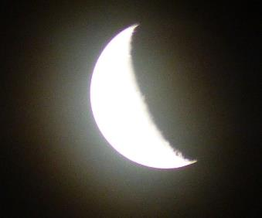
Throughout the night, my mind worked on the tire dilemma. By morning, the answer was clear. Go to town and throw money at it. But first, call Les Schwab, the corporate tire dealer in the county, and a 100-mile round-trip drive. For a mere $505, they could sell me a new tire and wheel. It’s good to have a starting number. I called Kevin next, the independent tire dealer, who was just a 28-mile round-trip drive away. He had a used tire and wheel, $80, mounted, balanced, and ready to go. I bought it.
I then spent two hours wrangling that inflated tire and wheel onto the front hub of the truck. Again, the sun was setting, and I had to drive the two rigs one at a time, leap-frogging my way home.
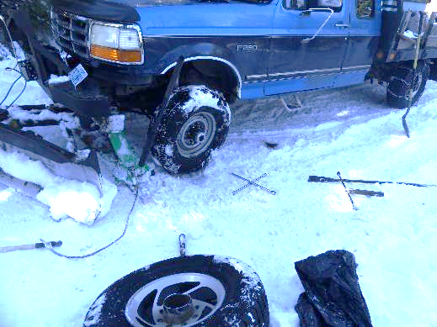
I found out for sure that walking downhill puts me in the running-out-of-control psychosis from whence face-plants come. Luckily, my truck was there to catch me. In my opinion, this abnormality is a result of too many blunt-force head traumas. It has been said that I lead with my brain, and the face-plants prove it.
Is there a fix for the malady? Who should I ask? I’d go to the VA, but as mentioned, I’ve been banned unless I bring in a police escort. Yeah, that’s how much of a threat they consider this old man to be. Their kangaroo court puts out pure slander and libel. The problem is social, and they treat it as a criminal issue. As they do with medical maladies, they want to treat the symptoms of the problem and not address the cause. That's a typical AMA strategy.
Another day of unforeseen challenges. What’s next? Get serious and begin the 2025 Sequester Game Plan on paper.

Setting Up the Game Plan.

Before any game is played fairly, all players must know the goals and rules. I’ll set both right now from my point of view:
A: Track the developments of the defined goals throughout this sequester in this diary.
B: Make it all fun.
C: Go deep and reach for the rewards of being a better me in the future. How to meld into old age.
D: How to act in public. That’s a hard one. People today are not fun. They seem to lack a sense of humor and don’t understand a gregarious personality from the early half of the 20th Century. That would be me, a comic standing up, sitting, or lying on a bed. The young appear not to know the Bill of Rights found in the Constitution. Free speech is the first and most important. The young do not understand that or allow it.
E: Focus on arts and crafts, from button production to music and storytelling.
F: Survive.

PSYCHOBABBLE
A recurring process of self-redefinition.

Before I take the first step on a journey to self-redefinition, I sit in my office chair and contemplate the path and purpose of such an expedition. Will I walk it alone? Will I call or email people and ask them to accompany me? No, I can’t do that. This isn’t anyone’s journey but mine. Wait! There is another entity involved beyond the personal, the Gawd Spirit.
Here's my belief, and I could be wrong. Gawd is the extraordinary spirit of all that was, is, and will ever be. The Big Guy. No! It is not male or female, yet it is always both and neither. “Big Guy” isn’t enough of a moniker for the All-Inclusive Greatness.
I’ve called it plenty of names. Supreme Consciousness is one of my favorites.
Still, Gawd is easy to write, and although it is not the ‘common’ English spelling, it works and does not lump me into any religion. For me, Gawd is not something separate from me. I don’t have to go looking for It. I am a small but relevant part of my Gawd. Without me, neither I nor it exists. This Gawd of mine doesn’t need me to recognize it any more than I need to acknowledge any part of my body as mine/me. When my nose runs, I blow it clear and wipe off the wetness for comfort. When my spirit needs cleansing, I blow and wipe off any debris. Refresh. Reboot. Redefine.
I want to build a bridge over a spiritual divide. Nothing solid. Come on, now. I am a fiction writer, and spirituality is right up my alley. Gawd resides in the metaphysical world, while we inhabit the physical world as sentient human representatives of Gawd. Together, we have both bases covered. We’re suitable to play chess, tennis, or a game of life and death.
I’m not one for praying and expecting anything to come of it. This is why I play the lottery. It is my best example of praying to the Great Gawd of Luck. Luck and extra cash are all it takes to make a difference in a person’s life. I would not mind some Divine intervention for the numbers I pick to come up on the lottery machine. I’m not full of hope or expectations when invoking Gawd’s attention or participation. There has been no big lottery win in my life yet. Why? Money is a manmade instrument, not part of the metaphysical and spiritual worlds.
In its unique manner, Gawd is there for me mostly whenever I need it, without me having to ask for an intervention. My life needs saving, and it’s been saved from whatever danger could harm or kill me up to a point. Accidents happen, and death is a guarantee. I can refer to my heavy combat in the war. Watch my award-winning documentary on my military exploits FOR FREE at https://bwizard.art/. It’s right next to the NY Indie Award Plaque.
Then, check out my overt incursions into the international crime world to fight the Nigerian 419 Scam Industry. Read the back cover of the “Don’t be Scammed! Be Informed!” novel. That’s me running with cops and criminals in the EU. Also, there is the “Game Over” 419 eBook or audio book.
https://bwizard.art/product/game-over-downloadable-audiobook/
For most of my life, I have lived in primarily lawless environments. Therefore, danger and damage could be around every corner.
Of course, countless motor vehicle incidents and self-induced stupid acts, almost all of which were walkaways, have occurred. I do love to push the limits of all things. It’s where the fun is.
From what I know about Gawd and how it works, most of my questions are answered within my mind. Is that where Gawd lives? I think not. My Id, Ego, and Superego occupy all the extra space within. My Trinity is Me, Myself, and I. We’re the only ones I have serious thoughts and communications with. I’m happy we are given free thought and expression. I shun those who rebuke our gifts of freedom. Indoctrination does that.
I should discuss the Freudian concepts of Id, Ego, and Superego. Freud had his psychological trinity and used the three aspects of the mind to explain how we think and act. I lump all three in with religious icons. The Father, Son, and Holy Ghost are all the same family regarding Christian ideology. Some religions have but one figurehead. Others have unlimited spiritual entities, forefathers, and the like as their spiritual guides.
Good news! I’m not interested in the indoctrinations of Freud, religions, or folklore. I’m a Freethinker. I am not a rebel fighting against somebody else’s sense of Gawd, Religion, social doctrine, or pure fantasy. It's okay if it doesn’t infringe on anyone else in a way that causes harm. I am freely thinking on my own. Why? Free will is a Gawd Given Blessing. Those who crush it need re-education.
I’ve been ‘alone’ and on my ‘own’ for most of my life. I have no one to confer with about my beliefs or, more to the point, ephemeral opinions. This is how the wild animals live, free of outside stories regarding something greater than themselves. Gawd includes all lifeforms, and each is part of the Greater Consciousness. It’s from all our lives that Gawd learns about Itself, grows, and one day, it will reach the pinnacle of Its self-awareness. That will be a moment of crowning glory for It and us. That may have already happened.
What is this leading up to? I need to confer with my Gawd Spirit and see if we can make the end of this life for us both a true success. That would piss off a lot of people: family, friends, even a few enemies. None of them want me to succeed as the free-thinking, non-conforming artist and spiritualist I live to be. I don't claim to be much different than other lifeforms, but I have my moments. I have a legacy, but I suppose such a thing is unimportant. A legacy is documented if one lives long enough and continues to grow, learn, produce, and achieve the near impossible.
My legacy goes deep and wide. On an artistic level, I have created many original pieces of art and form. On a financial level, I have been kept down to live, develop, and produce at the level of poverty. After all my work, I can’t seem to make the first penny of profit. My work never pays for itself, so I’m always out of pocket. That is a topic I must take up with my Gawd Spirit. This is wrong and will contribute more to a sad and sorry life of old age. If I had the financial wherewithal, I would hire a crew of caretakers—some for my historic real estate and others for me.
On a social level, I am a significant failure. My blood family has turned its back on me. Many people who befriend me in the end turn their backs on me, too. My relationships with women, including a wife, tainted my summation of love relationships as follows: The three most dangerous words in the English language are “I love you.” I realize how the whim of an emotional switch can alter chemical reactions such as love, jealousy, hate, and anger. Humans are quick to leave such baggage behind: disabled veterans, sick dogs, or wounded animals. Any superfluous baggage. What could a simple man of little means have to offer anyone worth two cents? Like many of them, perhaps nothing. Then again, such a person might have a historic legacy worth knowing. This is why I have documented so many aspects of my life.
These are topics for the upcoming discussion I intend to have with my Gawd Spirit. Starting with my sincerest “Thank you. Thank you for being a part of me and me a part of you. You are a great partner and backup when fully engaged in my survival. Let’s do more, but first, may I make a few suggestions?” You know I will.
The last Quarter of this Lunar Cycle is in play on the 20th. It’s the eighteenth day today. What I want to do after I ride out this transition between the third and fourth moon quarters is to set up all I need to run through the rest of the sequester successfully. I have many creative ideas to outline, if not produce. You’ll see.

BUTTON PROCESS TESTING

I have already made 29 stamped copper buttons. I did the inventory and found it 17 buttons short of my favorite stamp impressions, the Indian Head/Buffalo (Actually Bison) replica from the old five-cent coin. This is okay, as now I can put the process to the test with a second run. Completing a challenge is a good thing. It shows maturity. No one needs to be impressed, though, with only one attempt to win a game. One win of a game might have been a fluke. A new challenge of the same caliber must also be a success to prove the truth.
A break in the weather will come, which might inspire me to move the button process back into the cabin. The following two days will be much nicer weather, and I intend to do some serious outside work.

Wikipedia Page 419 Scam

There I was, minding my own business, as per usual, making buttons, moving snow, and enjoying the solitude. I was comfortably tucked inside my cabin, near the heater, food galore, electricity, and toys. I then considered promoting my website and all its beauty during this sequester. But…how? I don’t want to throw too much money at this process or have much upkeep. I keep receiving offers from Wikipedia Moderators telling me how they can whip up a great Wiki-page to fulfill my ambitions.
I know I don’t want to do the work. Here’s a sample of what they came up with:
Brian Wizard
Born | 1949
Nationality | American
Occupation | Award-winning novelist, filmmaker, sculptor, musician
Institutions | Sonoma State Uni, School of Expressive Arts
Industry | Independent Multimedia Art
Website | www.bwizard.art

Brian Wizard
From Wikipedia, the free encyclopedia
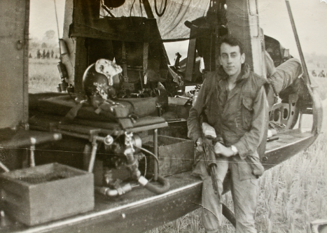
Brian Wizard (born 1949) is an American award-winning novelist, filmmaker, sculptor, musician, and independent multimedia artist. Known for his unique contributions to literature, film, and visual art, Wizard’s work is deeply influenced by his experiences as a combat assault helicopter door gunner during the Vietnam War. His creative expression and contributions have garnered attention in both the art world and among military veterans, as he reflects on the psychological impact of war and the transformative power of artistic expression.

Early Life and Military Service
Brian Wizard was born in 1949 and grew up early in the 20th century. His idyllic childhood was profoundly altered when he was drafted into the Vietnam War in the late 1960s. As a member of the 118th Assault Helicopter Company, Wizard served as a door gunner on the combat assault helicopter Pollution IV. This smokeship was frequently the first to enter hostile landing zones. The smokeships created protective smoke screens for troop-carrying helicopters, ensuring their safety from enemy fire.
Wizard’s time in Vietnam shaped his personal and creative identity, as he witnessed the violence and trauma of war firsthand. The stories of his experiences were later detailed in his book Permission to Kill, his documentary Viet Nam: “Then, Again, and Beyond”, and the article Smokeships Always Leading the Way. The stories of the Pollution IV and its crew performing death-defying acts of bravery have remained central to his work as both a creative and therapeutic outlet.

Artistic Career
After serving in Vietnam, Wizard pursued a degree from the School of Expressive Arts at Sonoma State University. However, he struggled to reconnect with mainstream American culture, leading him to emigrate to Australia. Wizard published his first novel, Permission to Kill, in Australia and spent several years living in Queensland. He hitchhiked all around the country, promoting the book’s second edition and supporting Australian Vietnam veterans.
In the 1980s, Wizard returned to the United States, relocating to the Inland Northwest. Isolated in a wilderness environment, he wrote numerous novels and created a wide array of multimedia works, including sculptures, jewelry, and musical instruments. His creative output is described as therapeutic, helping him to process and overcome the negative psychological effects of war. Wizard’s work is known for its unflinching portrayal of the wartime experience and the emotional toll it takes on those involved.
Brian Wizard has also written and published 17 novels of various genres, five award-winners. As part of his latest book, Life Immaculate, the Trilogy comprised three novels. He displays the four illustrated music videos from within the story for free on his website. Brian wrote and performed the music and vocals.
All his works are found at bwizard.art. Brian does not sell through bookstores, saving the reader money.
Brian Wizard likes to make short videos. The videos are both fiction and facts. He produces jewelry, and a musical instrument called Humming Blades, and stamped copper buttons. His website also offers short stories along with videos, text and artworks. His sculptures are originals in stone, wood, clay, and cast in tin or bronze.

Notable Works and Achievements
Brian Wizard’s contributions to both the literary and film worlds have earned him significant recognition. His 2005 documentary Thunderhawks, composed of actual combat footage, won the “Best Documentary” award at the New York International Independent Film and Video Festival. His dual documentary, Viet Nam: "Then, Again, and Beyond”, also earned critical acclaim for its compelling portrayal of his personal experiences and post-war life.
Wizard’s other notable works include Back in the World and Permission to Live, two books documenting his journey after returning to the U.S., as well as Make Friends Not War, a film about his return to Vietnam in 1999. He also gained recognition for donating the custom-painted combat helmet he wore during his service, along with his platoon scarf, to the Smithsonian Institution’s National Air and Space Museum in 2007. Shortly after, Brian located, purchased and donated a very hard to find Smokeship artifact: an original smoke generator.
Brian called Roger at the Smithsonian to ask, “You know that smoke generator you need for your Huey that has a history of being a Smokeship? I found a complete smoke generator for it. Will you install it if I send it to you, all on my dime.”
In addition to his literary and filmmaking achievements, Wizard is a pioneer in independent publishing and has been featured in prominent directories such as Who’s Who in America, Who’s Who in Communication and Media, and Who’s Who in Entertainment. He has contributed his name and work to various cultural institutions, including the Library of Congress and the military history archives, and even had his name placed in space through the Space Arc time capsule.

Personal Life and Legacy
Brian Wizard remained dedicated to sharing his experiences and creative vision with the world throughout his career. As an artist, he has continuously explored new mediums, producing sculptures, jewelry, and musical instruments, all reflecting his deeply held beliefs about the intersection of art and healing. His work inspires those who share his commitment to artistic expression and honoring veterans' experiences.
Wizard's work supporting the veteran community is not just a commitment but a significant contribution. He encourages his fans to support his creative endeavors by purchasing his books, documentaries, and other artworks. His ongoing creative pursuits and advocacy for veterans reflect his lifelong dedication to artistic expression and the experiences of those who have served in the military.

Awards and Recognition
- Best Documentary, New York International Independent Film and Video Festival, Las Vegas (2005)
- Featured in Who's Who in America, Who's Who in Communication and Media, Who's Who in Entertainment, and other prestigious directories.
- His combat helmet and platoon scarf are on display in the Smithsonian Institution’s National Air and Space Museum. (They have been for years, but the entire display is being moved to a new museum in DC in 2026.)

External Links

What I read is a very incomplete report. Then came the “up-sell scam.” This was the verdict regarding the validity of the Wiki-page from the higher-ups (so I was told). It did not come to me with any official Wikipedia letterhead or a higher-up's signature. To make matters worse, I can’t have a public report about me that has countless grammatical errors:

Concluding Remarks
The submitted draft's current score indicates insufficient
references from credible sources. Without substantial improvements,
the draft does not meet the Wikipedia publication criteria. To
address this, it is crucial to add citations from reputable sources to
enhance credibility and ensure compliance with Wikipedia guidelines.
Required Sources

Of course, it didn’t make the grade. The researchers didn’t do research that would benefit me. They left out the qualifying parts of my resume/CV, forcing a failure—not by me, but by them.
I called them and told them I saw an ‘up-selling scam.’ They wanted $3000 to $10,000 for their ‘special’ team to qualify my inclusion. “I’ll take the $10K package, please.”
No, I won’t. I will don the International Counter Fraud Hat I earned from six years of part-time fighting against the Nigerian 419 Scam industry and come down hard on these people. Yes, I’ll write and send sternly worded letters to the BBB, Wikipedia headquarters, the Credit Card I used, and any other place I can find. News outlets come to mind.
Of course, I then asked for a refund. I was told I would have a refund within 24 hours. That means I should see the credit recharged to the credit card I used soon. If I don’t see said chargeback within days, I will start my campaign of fair warning to the world not to take part in these junk email offers. It's one more fun thing to do during a sequester.
This is a talent I have from back in the day of fighting the Nigerian 419 Scam industry from 1999 to 2006. I spent many winter months doing my part to educate the public and combat the scams' success worldwide. I was able to get 12 financial terrorist cells in the Netherlands shut down and the scamsters arrested. How? By doing a full-page interview with the country’s largest newspaper. You can find said story on the back cover of the “Don’t Be Scammed” novel on my website in the Book Catalog.
https://bwizard.art/product/dont-be-scammed/
I lived with another night of suspense. Yes, I spent $400 trying to get myself a Wikipedia page, but ultimately, I bought a chance to stop an ongoing scam.
Oh, as a GFY gift to me from the scammers, there are hundreds of junk phishing emails filling my old inbox. It’s always something fun.
I had more suspense through the second night and into the following day.
I held onto the suspense of not knowing if the Wikipedia Scammers refunded my money by performing all morning internet duties: news, email, and banking. Holy McMoly, the Irish in me came through. The credit card I used did indeed receive the refund. I won. My money has been returned. It is only $399, but returned stolen money is FREE money I get to spend again. This is the only condition in which I like double handling. I also have the draft Wiki-page to use wherever I want. That’s funny. Did I steal from the scammers? I don’t think so. Wikipedia HQ disqualified the page they made, so they said, although it does hold some value.
Here are the payment and return records:


With the legacy of working as a private contractor in the fight against international fraud, I still have the talent to defeat such scams.
As you’ve read, I'm trying to redefine myself as a New Old Man with a new name, Brian the Olde, with an e. It's a process of shedding my old talents as a Master Expressive Artist and embracing new ones. Out goes the focus on artwork, and in comes... what? What will the newly redefined me look like, act like, and do? It's a question that keeps me intrigued and excited about the future. I reckon it will take eighteen months to define the new me.
This dead leg shows me where to stop plowing during the next downhill plowing on Whisky Creek Rd. At five miles per gallon, when pushing snow, there is no need to go further than necessary. There is a happy predator up in that forest. I have one less deer to feed.
Does anyone need a leg up? I have an extra one.
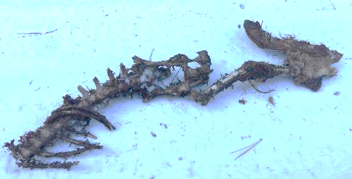
This is the ridgetop. Oh yes, I have plowed it wide often. It is where the snowdrifts form and make the hardest, compacted deep snow.
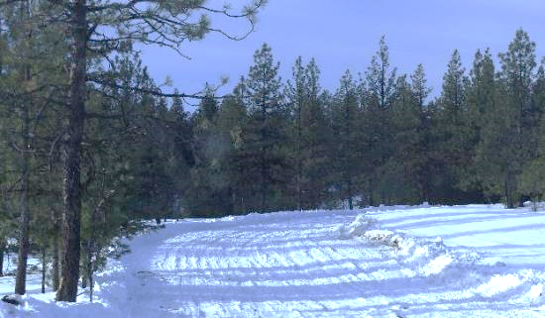
It took a month to manufacture 58 buttons. I could use some help deciding which look is more attractive.
Is it the all-copper look or the black background with the shiny image? With all blurriness aside (too dark, slow shutter speed), which one?
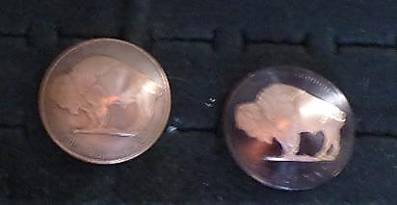
The problem with the black background is that it is the ink of a felt-tip pen. Will it wear off quickly? If so, will it wear off in a way that will make it look antiqued?
I have 29 of each.
I reckon I have a jacket to put a few on. I’ll wear it around as my display board.
If the word is that the black one is the most popular, I can turn the bland ones black, too.
At first, I thought this was zodiacal light.
Jokingly, I called it the Christian Rapture, taking all the good Christians out of Wallowa.
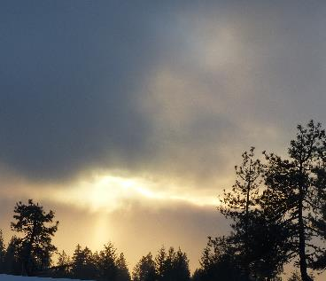
But to be ‘zodiacal,’ the light would have to be reflecting off cosmic dust particles before dawn or after sunset. This was pre-sunset. Just a beam of sunlight, I reckon.
Here’s a photo of real zodiacal light. (Not my photo.)
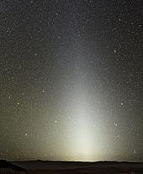

A Walk and Talk

Into my seventh week of this sequester, the time and outside conditions were right for a walk and talk with my concept of Gawd. The first question was: How do I make a secure connection to the omnipresent Spirit? The best I could come up with was, “Take a walk with It and call it out for a focused chitchat.”
For weeks, I have thought about how this meeting of the minds would occur. Why walk? Walking on a layer of ice with a snow cover can be tricky. Ruts can still be frozen yet have an inch of slickery snow on top. I donned my winter clothes as the 29 degrees of snow-filled air needed a hat, scarf, jacket, gloves, and cleat-installed traction devices on insulated snow boots. As I walked toward the door with an outstretched hand ready for a twist of the knob, I spoke with my Gawd as if It was inside the cabin with me. I laughed at the idea. “Meet me outside for a walk. We need to talk.”
I would know of Its presence the same way we make our mental connections whenever It wants to talk to me. After all, it’s me talking to me, and It talking to Itself. This keeps our attention focused. “Tell it like it is with no sugarcoating, lying, or betrayal,” is my attitude.
The silence of a snow-covered forest is always deafening. That’s one aspect of the snow cover that I appreciate. A generator can run twenty feet from me, and I won’t hear it as loudly as I would without snow. This is one of the calming aspects of living in a vast forest. No one hears or sees me. I see this as making myself invisible to all humans. The wildlings see me, so that’s good. When they no longer see me, I’ll know I must be dead. I’ll probably be the last to know.
Can a believer ever make themselves invisible to Gawd? I think not. Can a believer commune with Gawd? We’ll see. I think so. It might be called praying, but to oneself, one’s Gawd. Maybe… what do I know? Whatever I can make myself believe to be a fair opinion sounds like a good choice for public discussion. We have a right to an opinion. Constitutionally and humanistically. No one can steal or change that right. Not family or friends. I have experienced the turncoats of friendship regularly as they, all Democrats, don’t believe or give me my freely gained and expressed opinion. I must accept their way of thinking or lose their friendship. How unfair is that? Very.
I fail at conventional prayer, so I will say whatever comes to mind as I step outside and trek around the property. I will call it a perimeter check, noting any upcoming forest cleanup tasks created during last year’s logging operation.
“Gawd, you there, here, somewhere? Location doesn’t matter if you are paying attention. Like I said,”‘We need to talk.”
The sounds of my footsteps broke the quiet of the snow-insulated forest. I have two things on my mind that need constant focus: safely walking over and through treacherous forest ground cover, which includes snow, bushes, branches, ruts, holes, and an ever-changing collection of snow-covered debris that can’t be seen. It’s easy to twist an ankle or trip and fall on…?
My Gawd’s response didn’t make a sound. It came into my mind as if it was spoken within.
“I know all your questions, and I know all the answers. Which category of interests do you want to discuss?”
While I was gathering my thoughts, an image flashed through my mind. I saw $ $ $ $ $ $ $ $ $. Yes, that is an ongoing, unanswerable question. I don’t want to waste my time questioning the unanswerable. Money is a manmade financial instrument. What would a Gawd know about it?
Another image flashed within. This was of the Huey helicopter on display at the Smithsonian Air and Space Museum, which sports the hard-to-find authentic smoke generator equipment that I donated. Yes, for a moment, I just happened to have one that I bought from the Friends of Aviation hangar. The staff told me about it after hearing me announce that I have a video of Pollution IV, the Smokeship I crewed on.
“We have a smoke generator in that box right over there,” a staff member told me.
“In that box, right over there?”
“Yes, sir,” he confirmed.
“What are you going to do with it?”
“Sell it, trade it, we don’t know.”
“I’ll give you a thousand dollars for it right now. I’ll ship it to the Smithsonian in DC.”
They took the money. I called FedEx and paid $120 for a special VIP shipping rate.
On my website, you can watch a short video of me dedicating my custom-painted flight helmet, platoon scarf, and other items in a glass case at the National Air and Space Museum in Chantilly, Va. https://bwizard.art/bw_videos/video-brian-dedicates-his-vietnam-combat-gear-to-the-smithsonian-inst-natl-air-and-space-museum/
Please scroll down to see the longer award-winning video, Viet Nam: “Then, Again, and Beyond,” in which some Pollution IV crew members and I dedicate the smoke generator I located, purchased, and donated. It is now installed on the Huey, which has a history as a Smokeship.
All this gear will be transferred and set up in the refurbished Smithsonian Museum on the National Mall in DC in 2026. I get the favor of a second dedication of my combat gear and praise for being allowed to gun on the amazing Pollution IV smokeship. The curator, Roger, told me that my gear would be a part of the centerpiece of the new Modern Aviation display. CENTERPIECE!
Pay attention, children. This man has proven that if we do not forget our dreams and don’t stop working to make them come true, we will not lose a well-earned historic legacy.
A news report told me that if I worked in a government job, I’d have to write a report listing five things I did last week as part of my job performance.
I feel sorry for people working at the same repetitious job daily. My way of working is doing as many unrelated tasks as possible daily. But that's just me, a freethinker. I follow the rule: A change is as good as a rest.
Still, I did a few things last week.
1: I finished the copper button project, creating 59 small creative wonders:
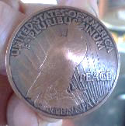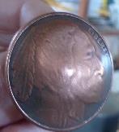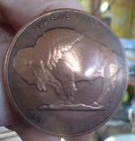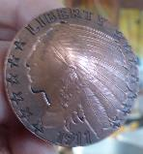
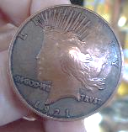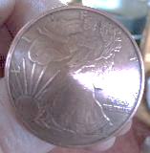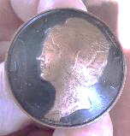
2: I also sold six for $20 each asking price.

Hey Brian-

Ok, sounds good.
I'd like 6 plain buttons (not blackened), $120.
Do you take PayPal or Venmo?

BG.

As mentioned earlier, I was exposed to commercial and online promotional scams and successfully fought them: Wikipedia and Google Ads. (These are more things I’ve done, numbers 3 and 4)
For number five, I sold an eBook from my website to an avid reader in Massachusetts.

Description | Unit price | Qty | Amount
Permission to Kill  Item# 15640 | $9.00 USD | 1 | $9.00 USD

The buyer then watched the award-winning documentary that brought the words and images of the story to life.

Review of the story: “Fantastic.”
Review of the video: “Great documentary!”

I do love it when a plan comes together. I need more days and people like the above. Those two lines of praise and success are of more value to me than a listing on a Best Sellers list.
Now, where was I on the walk and talk? Oh yeah, reviewing my thoughts as I waited for Gawd to shine Its light on me. This brought on the statement I expressed earlier regarding what I must say first.
“Thank you for all that you have done for me. For a long time, I couldn’t fully understand the purpose of some of what you arranged, like the war, its death and destruction, and the struggle dealing with the aftermath. It was a precursor to much of my future. I see that now, and I accept it as fair. Your guidance and protection allowed me to become an alive somebody through books, movies, history, and songs. I remember talking to my cousin Eric when he asked why I was joining the army. “’I’d rather be a dead somebody than a living nobody. I don’t have much potential to become significant.
Your Uncle Marsh has a stone monument in front of the local library for his sacrifice in WWII. I would like something like that.’”
Now I see how I received the best of both options. All the awards, plus the inclusion within the walls of the Smithsonian Museum, went far beyond my dreams. You are an amazing Gawd. Good to have you as a friend.”
That had to be enough “kissing up.” Now, down to business.
Even though no words were spoken in reply to my last statement, It gave a short chuckle.
“I called this meeting to discuss the future, not the past. We did well, and I’m proud and happy about our successes. What’s more important now is our dwindling future. How and where to live, and what serious goals will be achieved? Then, for a grand finale, what will be the circumstances of my demise? Something spectacular, I hope.”
My Gawd replied, “The future is not written in stone. Your choices direct your movement through time and space. You might have noticed how I don’t make choices for you. All I can do is set up the opportunity for you to choose, good or bad, right or wrong. Although it is said that all events are predetermined, the truth is that all choices direct the future’s makeup on a choice-by-choice basis. The future is constantly in flux.”
Dang! I felt put on the spot. I’m always willing to choose, but it is hard without perspective. “Does this mean I must choose the winning lottery numbers for the upcoming draws?”
“Yes,” It told me.
“Therein lies the problem. No matter what I say, it will be speculation at best.
“I understand your lack of confidence. You’re trying to write a fun, profitable, success-filled plot for your upcoming story about the end of your life. You’ve written screenplays, scripts, and stories before. You have a knack for it. You know that. Therein lies your confidence. Just do whatever makes you feel you are putting opportunity on your side.
You chose the opportunity to join the army, go to war, and become a war-hardened soldier. Good call, I say.”
“Well, thanks,” I spoke aloud. It felt good to be noticed in a positive light. “So, what about the future?”
“I guess you will continue chasing fame and fortune regarding your past creations, reputations, and dedications. I find you quite entertaining, and this is due to your spontaneous ability to think things through. If you want a spectacular ending, make it happen. It’s your ending. Between now and then, old age brings limits. Find your comfort zone and work it as if you own it, as you will.”
As I digested all that, I fell silent.
“Are we done?” Gawd asked. “Any comment on your future options?”
“Yes, one choice feels dominant. I know where I have been, I know where I am at, and I know where I am going.”
“And that is?”
“No place special, but the core of my next phase of life will be to mix it up. Change the old for new and become, Brian the Olde, yet New. I will live my own life immaculate.”
“If I see a great opportunity for a spectacular demise, I’ll guide you to it,” Gawd volunteered.
“Okay. I’ll be open for suggestions.”
I suddenly felt a weight lift off my spirit. “We’ll do this again, and feel free to influence my lottery number choices positively. Second place is fine as I’m not a greedy man.”
There was no verbal reply, but I did feel a smile in the air.
Some of that smile was mine. Its words put a fact in my head that only I could create. My next and last novel will be book number four of the Will He Make It Saga.
As you might know, my first novel was Permission to Kill. Then came sequel one: Back in the World. To follow that, it was only logical to create Permission to Live. I’m a very logical man, so there must be an end novel, “Permission to Die.” I like it. It brings my life full circle, as my life is from whence the material for the saga emanates.
I returned to my cabin, turned up the heat, got nearly naked, and went to bed. I do my best thinking in that almost dream zone.
Gawd’s words repeated inside my head. “I don’t have to change anything, or I can change everything.” To me, that’s called freedom.
I can see winter's end as I get the first sun of the year within the confines of this deck chair. Cocktail hours are scheduled soon after the rodents emerge from their subterranean dens. There is suspense around the question: Will adult beverages be at these parties for me? I’m not drinking any cocktails during this time of isolation. If I take a serious break from drinking alcohol, will it make any difference to my long-term mental or physical health? It won’t make me look less goofy.
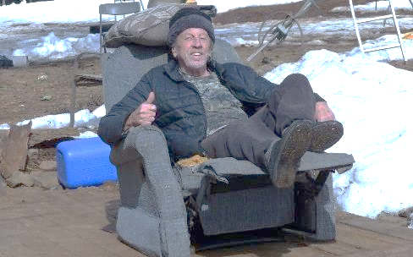
I spent the day cleaning and organizing the cabin, dishes, and a pile of dirty clothes on the floor. Then, I worked on this story. Like any other story, it required concentrated thought. It’s good to focus on something with detail and challenges.
I looked at the stuck truck. There was no interest in working hard to extract it from its snowbound parking place. There’s always tomorrow.
The next day, I awoke to turkeys squawking and talking just below my window. I felt the Light of Gawd shine around and into me. It was 5 am, right on time. Dawn was breaking the horizon, but daylight had yet to bring its sunny disposition.
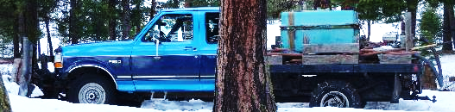
“Let’s talk,” My Gawd inserted into my mind.
“Okay. Can I get up, or should I lie here?”
“You can get up, and no lying. This talk will be serious.”
I felt Gawd’s good humor was a fun way to start the day. Up I rose and immediately had to pee. Since I don’t have indoor plumbing, as I peed into a plastic coffee container to dump out later, I asked, “What brings this unexpected visit?”
“I could have told you more during our last talk. You have more questions, and luckily, I have more answers.”
“Am I supposed to guess at the questions, or can you hint at what I must ask?”
“I’ll ask; you answer.”
“I’ll try.”
With my hands washed and a cereal bowl ready to receive some bagged granola, I poured and instructed, “Fire away, make me smile.”
“What is most important for you to do today?”
Looking out my back window, I saw the snowplow truck stuck in the ice and snow. Its rear right tire was buried six inches into the icy ground heave and snow.
“I would love to get that snowplow free from its captors and parked in its assigned parking space.”
“Get dressed, and we’ll do it.”
The difference between yesterday and today was that the three-inch-thick frost heaving around the bottom of the tire yesterday had receded due to warm air and some rain. This made the six-inch deep hole that held the truck frozen in place less deep and less resistant.
I did not dress for being outdoors too long. It was cold, with wind, but not freezing. Still, I had to try since I had someone to help. I sat behind the wheel, started the truck, and reversed the transmission once the engine was warmed. Gently, so I didn’t spin the back wheel and dig the hole deeper, I attempted to move the truck. The back tire needed to climb out of that hole. Using my winter driving skills and the V-bar chains, I moved the truck six inches forward until the plow hit a stump, then back again, packing down the crusty layers of loose dirt. Forward and back again. “I could do better with a bit of Divine Assistance,” I suggested to my helper. “When the tires rise out of the hole the best it can, lift the rear axle so the tire will find a flat spot,” I advised. I gave the truck a final backward push, pushing the loosened dirt to its stability limit. When I felt the chain-wrapped tire was about to spin, the rear axle divinely lifted out of the hole and found a place on solid ground.
“Thanks for the intervention.” I was free to drive on. I plowed around the yard, across the ridgetop, and down to the W.
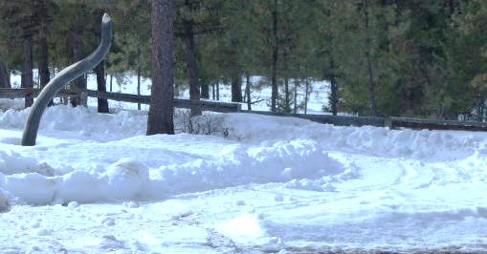
The snow is hard enough for me to walk on without falling through. This causes the heavy metal plow to slide across the top of the ridgetop snow instead of biting in, crushing it, and moving it out of the way.
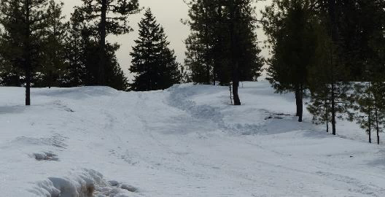
This is another nice photo of the Seven Devils in Idaho.
Do you think it has bathtub/shower curtain appeal?
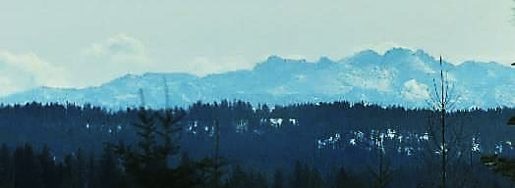
I am saving money on fuel by not plowing all the roads. To fill both gas tanks costs $120, once every ten days, twice more before Spring takes over. The usual date for opening the road is April 15th.
I will go shopping for food and do laundry. For fun out of the forest, I might rent a hotel room and enjoy some hydrotherapy. I want to try swimming to see if it encourages vertigo. If you hear that I drowned, the vertigo question will be answered positively.
I’ve done some research on vertigo. It is mainly caused by loose crystals used for balance within the ear canal. Not always, though. There are also visual triggers. This is what I found, and the good news is that the article clearly states that head trauma may cause visual vertigo.

Visual vertigo usually happens when there is a mismatch of focus between the eye lenses. Their focal lengths are different due to the blunt force trauma moving one eye lens out of sync. This causes the brain to get mixed signals.
Dizziness, blurred vision, and falling are all vestibular disorder symptoms.
(You can read more in detail at: https://www.webmd.com/brain/vestibular-disorders-facts

This is what makes me break into an involuntary run. The ground shrinks into tunnel vision as it speeds beneath me. I run faster by the second as I must keep my feet up with my head. If I had a video of an occurrence, we would see me bent over at the waist, running as if I knew where I was going. Of course, this makes my body front-heavy and leans closer to the ground until contact is made.
I’ve had more than my share of traumatic head injuries, from concussions to Traumatic Brain Injury. Once a year for three years, plus another half dozen over the past decade, my head has been bashed by falling. My first brain injury came with a case of ‘rattled brain syndrome’ made famous by adults shaking their babies too hard, bouncing the brain around in the skull cavity. For me, it was that controlled helicopter crash in Viet Nam after we had a shootout with enemy soldiers on the Cambodian side of the border. My eyes and brain shook hard as the skids slid across the hard dirt runway at Tay Ninh.
The last bout of head trauma in July ‘24 left me looking like this:
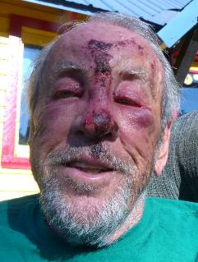
After that shock, I repeatedly replayed the scenes of the incident in my mind. The good news is that the physical damage to the outside healed quickly.
This is me a month later.
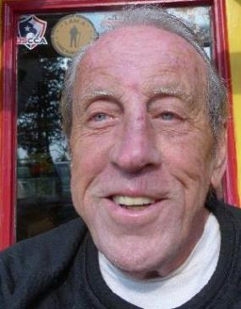
I suffered more damage on the inside: a bruised and swollen brain, loss of smell and taste, bruised front teeth, short-term memory loss, and more imbalance. I can still feel the spin of vertigo just beneath my consciousness.
The greatest pain was the compound fracture of a sliver of nose bone protruding through the skin between my eyes. Once the swelling receded, a fingertip touched the sharp bone’s exposed tip. It felt as if a needle had been pushed into my face, which told me the other end was also pointed.
I took a pair of tweezers, jabbed the tongs into the irritated skin surrounding the bone splinter, tightly squeezed the tongs, and jerked the pain-causing bone and surrounding irritated flesh out of the skin. “AHHHHHhhhhhhh, that feels better.”
Today, my sense of smell is back, my gums have healed, and my balance is better. However, I am gun-shy when walking downhill, and I can feel the imbalance pulling on my head. You’ll see that I have since purchased a cane to counter the imbalance. I have yet to use it.
An eye patch might counter the inner focal imbalance of one eye’s focal length different from the other. This is a work in progress. I can see the mismatch of the two lenses on a computer screen. I see the dot of a period seen as two dots when using both eyes. One is higher than the other. When I close my right eye, I see two periods. When I close my left eye, I see just one.
After being caught in a landslide whilst rock hunting in Southeast Oregon, near Owyhee, I smacked my head on a massive boulder after the ground I was standing on stopped sliding. This sent me for a run on my own, out of control. I was laid out on the desert floor, feeling like I had failed to ride the dirt to a successful end. I then felt elation at feeling alive. I could have broken my neck. Blood streamed from the multiple lacerations on my forehead. I had to drive 145 miles to the ER at the Boise VA hospital. The report was: minor concussion, and skin abrasions.
The attending doctor thoroughly checked me out and reported that I was alive and able to continue my way home. I did not get far, as I didn’t feel up to the next four-hour drive. I spent the night in a motel in Ontario, Oregon.
With the snowplow truck back in operation and a new list of projects being set out, I opened this complex issue with the goal of writing four seasonal photo letters. Its working title is The Sequester Story. The mornings are still too cold to enjoy working outside, and the sun warms the dirt into mud, so going out to work in icy and muddy conditions keeps my outdoor excursion short.
This is to say, late winter keeps me inside except for a few hours midday. I think I have done some good storytelling within. It felt good to me. You won’t like it as it will be at least 20,000 words of what might be considered BORING home life reporting. It’s nothing short of “Senseless Chatter.” A novella just the same. This is in fulfillment of another guideline stated in the project list. What excitement happens to a guy way out in the bush, alone, through months of being shut in, or as the more significant case may be, shut out of society? By choice, mind you. Ah, the bliss of it all.
I’ve also restarted the mouse-killing project and killed 18 this year. I swear I have the fattest mice in the forest.
This task had the extra gift of a hearing test. The traps were forty feet away from me, in the kitchen, a building separate from the cabin, and I was ten feet higher than the traps that sat on the kitchen floor. In my loft bed, my head hit the pillow, and I took a moment to review the day. That’s when I heard the snap of a trap. Yes, it was a good day, and my hearing is sound.
This is why I don’t drive down the hill haphazardly; I can’t tell the depth of the snow. There is a dip in the water bar where the snow tends to drift into a higher level than the rest of the road. I did that last year, and it took four days and a lot of shoveling to get free.
I do like the wavy shadows in this photo.
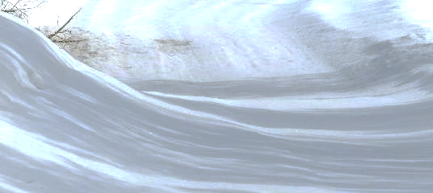
The high country.
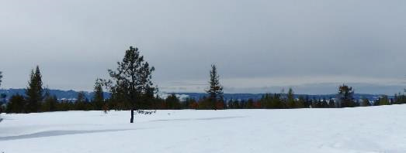
These two snowdrifts, which you see smashed and plowed, are not new, but they are more significant than before last year’s logging operation.
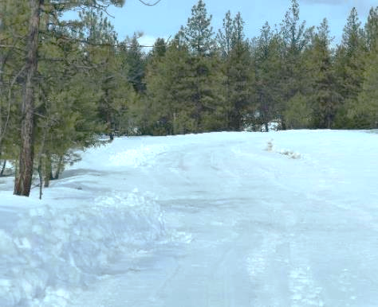
I had to hit that snow with some extra oomph to get a deep cut into and under it. I like crushing the frozen snow haphazardly into various shapes and sizes and watching the pieces fly up and out of my way. I’m easily entertained.
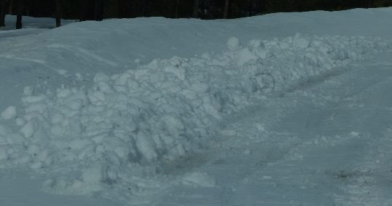
The true culprit of today’s inability to get out is a thick sheet of ice under the snow. Snow on ice is very slickery. Water on ice is the worst.
There are excellent long-distance views from all angles of my mountaintop, but I like to honor the easiest ones, which are few at this time of year due to my inability to drive the unplowed roads.
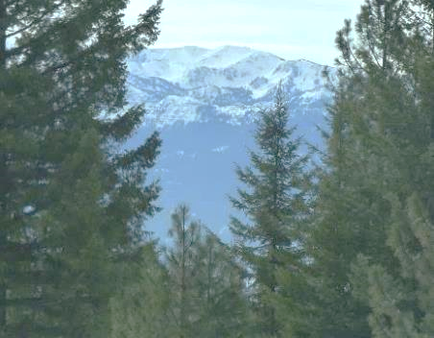
Time blew me past the First and Second Quarters.
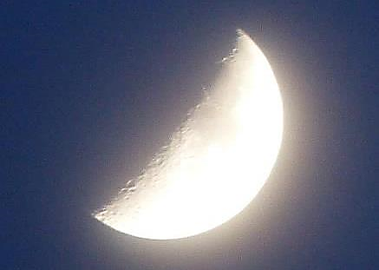
It was full of fun with the button project done. I finished with fifty-nine. I received an order for seven at $20 each, with one for free. I want to hold a stock of ten for tips and the like. I’m down to forty-three, with more orders said to come in soon. I’ll guess at six more, leaving me only 37 to go. I can do that over the summer. The Injuns are coming to town in July for their annual Pow Wow. They have a market for handmade items.
Two male and female turkey flocks now spend the nights in the trees above me. My morning salutations are replied to in unison, harmony, and with a hint of jazz. (There may be a video of this morning routine at the end of the story. IF I can figure out how to make it work as such.)
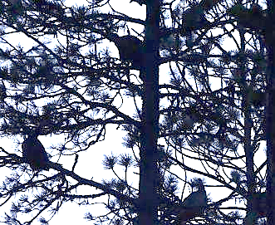
Next to me, they have the best roost in this forest. During the day, they roam the forest foraging for anything fun. They end their days wandering home to spend the night in their favorite roost with Mr. Man, who tosses them bedtime snacks of seeds and grain just before they go to tree for the night. They use me as protection as I sleep not far away.
When it is time for them to go to the treetops, they will fly.
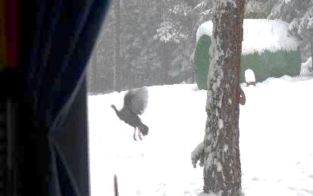
They sit and watch the sunset, the daylight turns to dusk, and the parade of celestial entities passes by. Here is the Moon and Jupiter parading two days ago. Jupiter will be on the other side of the Moon by now. The next show will be Sunrise.
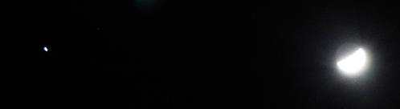
Is anyone up for a Third Quarter Moon? I’m ready.
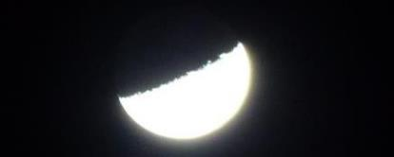
I’m also ready to sit in this chair to share Happy Hour with whatever wild beasts want to join me.
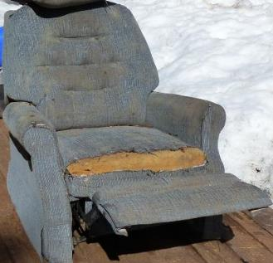
This slush will soon drain away in three weeks, maybe.
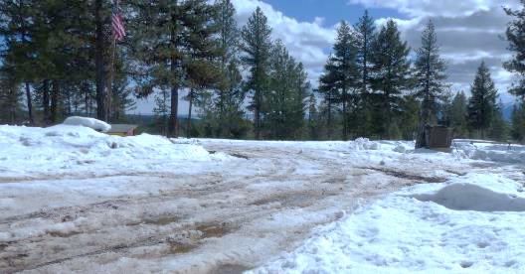
I’ll start this new art project: Palm Frond Faces. A few years ago, I pruned a short palm tree in Florida. I brought home fourteen fronds.
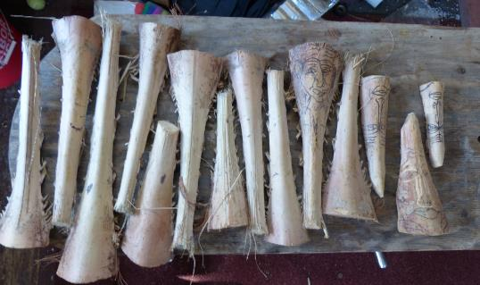
Fourteen is a lot unless I make the process easy. I bought a new array of high-speed carbide carving bits and a new high-speed drill. I’m ready to carve and sculpt. All I need now is pleasant weather.
Here’s one I started last year, a work in progress.
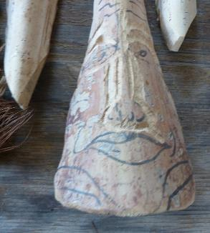
I finished this one several years ago.
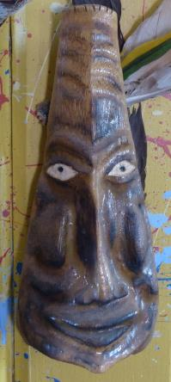
Just a bit of creative fun, really.
When the time is right, I will plow the driveway to bust a hole…as far as I need.
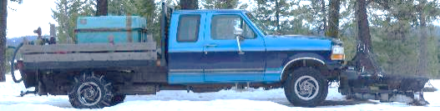

Talk 2: Shuck’n and a Jive’N whilst driving.

One sunny morning, as I put on the second snow boot with traction devices, the light streaming through the window increased, as it did in my heart and head. I felt the closeness of my Gawd.
“We need another talk and walk. I have questions,” It announced.
“I have answers,” I retorted in a teasing tone.
Some folks might be startled by a sudden invisible presence talking in their head, but I’m used to it.
“We won’t be walking; we’ll be driving, as I need to test the snow’s willingness to be plowed.”
“It’s too soon unless you want to fight the elements. The truck will get stuck.” It warned.
“Well, we’ll get it unstuck. We have the power.”
I know better than to argue with any Gawd. Pure futility. “This is why I’m running a test: to see what the condition of the road conditions are.” I added,” So, what’s on your mind?”
“Are you aware of the Christian holiday Lent?”
“It’s mostly Catholic. I’m not a practicing Christian, never mind a Catholic, so I can’t tell you much more than what one of my Protestant sisters told me when she married a Catholic.
‘Lent is a period of prayer, fasting, repentance, and almsgiving in the liturgical year, commemorating Jesus' 40-day sequester from temptation while living in the desert.”
I teasingly asked myself, “Only forty days?”
“Lent and the Islamic Holy Season of Ramadan begin at the same time this year,” Gawd continued. “Ramadan commemorates the time the first chapter of the Koran was delivered to Mohammed, as well as Jesus’s sequester into the desert. Both celebrations last around a month, forty and thirty days, respectively.
“Good to know, but why are we discussing these religious holidays?” I had to ask.
“I wanted to give your sequester relevance to other spiritual activities since all three have similarities.”
“I’m not sequestered due to any religion,” I emphasized. “I’m having spontaneous fun whilst copping some isolation time away from the maddening crowds. I am conversing with you, my Gawd, during this time. That’s some praise-worthy spiritual activity, I reckon.”
“Yes, exactly. A time of isolation when you are consciously, or not, paying homage to… well, me and us as spiritual beings.”
“I don’t know how the Catholics or Muslims pay their homage. I’m trying to find the best way to reinvent myself into Brian the Olde.”
“In doing so, you are sacrificing your old ways for new ways. No alcoholic drinks, no spending money, and little in the way of outside influences.”
“True, although I do have the internet, its email and news,” I countered.
“How’s all that working for you?” It asked.
“Yes, I am sacrificing. I’ve lost almost all interested email recipients by sending them a look into my isolated routine. I always thought people who don’t live out of doors would find my life fun and interesting. Maybe I’ve overexposed them to a simpler life that they can’t have. I’ve lost a lot of friends from religious, political, and social differences.”
“But you are sacrificing,” Gawd pointed out a second time.
“Willingly, as well as practically. I’m not driving anywhere as I can’t.”
“Your choice to isolate is for the same reason Jesus and Mohammad had. A new spiritual awakening and rebirth of life.”
“You’ve convinced me. I’ve joined two religions, and created my own, of which my fellow spiritual pioneers are invited. I’m such a party animal. This is important to you because?”
“Ramadan will end March thirty-first, and Lent on the twentieth of April. All that is pretty much your schedule, too. Correct?”
“Pretty much, give or take. One correlated event is that April 20th is the day I truly could have died in a rice paddy in Viet Nam. Too bad my spiritual quest won’t cover that.”
“And I influenced a few key elements that prevented your death in that rice paddy, didn’t I?” Gawd stated with satisfaction.
“Survival was pure Divine Intervention, or it was pure luck. They are hard to distinguish from each other.”
“It was me.”
“Good to hear. I was wondering all these decades how that worked.”
“This is why I’m pointing out the timing of the two religious holidaze. They are exactly what you are celebrating or will once this sequester of yours is over. Rebirth. Plus, that’s what Spring is all about.”
“Dang! I now feel swamped. Do I have to have all my ducks in a row regarding the new me by these deadlines?”
“No. You only need to set a mental foundation. It’s somewhat like New Year's Resolutions. A reboot, rebirth, and new beginning. You’ll become exactly what defines your destiny.”
“What will that be?” I had to ask.
“A content old man.”
“One who dies spectacularly?”
“Could be, we’ll see.”
“Nice, very nice. Discontentment has always been a driving force in my life. It’s why I can do so many different tasks. Discontentment sets in when I’m partway through a project, so I stop and start a new one instead of getting frustrated that the previous one is not yet finished. Change is as good as a rest. Then, one day, after I start and stop a few times more, yet working steady-steady on a part-time basis, I might have several projects finished simultaneously.”
With all that said, I was ready to go out into the cold air and see if I could get the snowplow truck unstuck. “You’ll help unstick the snowplow, yes?”
“Of course.”
“Is there anything in particular you want to ask me?”
“Oh yes. I never understood the beauty of isolation,” Gawd admitted.
“Why not? You live it.”
“No, I have all the minions to keep me company.”
“No. You keep the minions company as I do the wild beasts that visit me. Even though they are different, they turn to us for our kind generosity.”
“Your kindness is good. I learn from you. You’ve lived an amazing life, and you don’t mind sharing. Thanks for being so open,” my Gawd replied.
“It’s the way of the gregarious. We don’t mind sharing or being shared with. I’m here to help.” Yes, I was a tad arrogant. I felt somewhat giddy, realizing who/what I was conversing with.
The questions came one after another. My answers followed suit.
“Where’s your woman?” my Gawd asked.
“With yours,” I joked. “Where’s yours? We could pick them up, double date, have some quick sex, and then unstick the truck,” I suggested. “Or we could woo them with some extended foreplay and love them up for hours. The truck can stay stuck until May.”
“Oh,” was the only response.
“Me, I don’t have much luck with women or friends. Both find ways and reasons to kick me to the curb,” I admitted. “Hence, my living alone in this huge forest, by choice, fate, and your intervention.”
Gawd held a silence between us, as if it was thinking about what to say next.
“You do know what to do when friends and lovers leave you, yes?” It asked, with an infliction of voice that told me there is a trick to this question.
“You know I do. Make new ones,” I confidently answered. “The older we get, the less likely the oldies will find anyone willing to befriend them. Young people don’t want to know old people. It’s a generational gap that both sides cannot ignore. The young are too young for the old to relate to, and vice versa.
“Plus, throughout life, as we age, our aromas change,” I said to expand the range of this topic. “The teenage emergence of hormones and pheromones helps attract a partner to further the species. Finally, the old-age chemical called nonanal blocks the idea of reproduction and attraction with its not-so-attractive aroma. The young rebuke the stink of the old, and it is a natural act.
“With age comes the natural loss of family and friends via death, so the field of possibilities shrinks even more. We become immobile and can’t get around independently. Those who don’t have the money to buy assistance can be placed voluntarily or not into a state-run nursing home. The old folks’ prison. Sentenced to life imprisonment for the crime of not dying young, dumb, and full of fun.
“All those reasons to avoid the young of society are what make living alone far away from people easy. If you can smell me but not see me, I’m most likely dead. I think many of the folks, young or old, don’t visit like they used to, as they fear they might be the ones who discover my dead carcass.”
This writing project takes hours out of each day, if not days out of each week, and weeks out of the seasonal sequester. It’s good, as the outside elements are not conducive to fun or production. This is when it is excellent not to have alcohol or silly TV on hand. I would become an alcoholic as I have found THE drink I like: Redemption Rye—42% alcohol. A little bit will do you. Too much over time will kill you.
“Check out the page and word count. Both grow daily. Someone has something on his mind and wants to write it down so he can read it and share it. I hope it is no more than 20,000 words. Seventeen thousand five hundred words turn a short story into a novella.
At this point, 99 of 159 pages, 20k+ words. I’m reaching for the 23238 final word count.
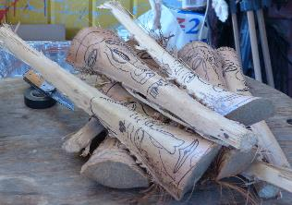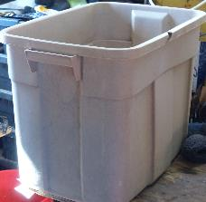
I drove the palm face fronds to the workshop. I need 50+ degrees of light clouds and a breeze during the high-speed carving. I want the particulates to blow away so I don’t need a mask.
The estate is humming along like a well-greased machine. Be careful of whom you put in the driver’s seat.
I could use some outside influence to entertain me. Like a small bevy of young beauties lost in the forest needing help, to a phone call from the lottery informing me I have won big. Both will kill me, leaving me with a smile on my face.
My friend E in Auz told me about his pioneer pops and how he used a car’s hood as a sled to haul stuff around the yard. I emailed him to say, “Great minds think alike,” and showed him the beginning of the Spring cleanup.

E,
You mentioned how one of your progenitors used a hood as a sled. I might have responded, “So do I.” Well, here’s the action to illustrate how great minds think alike.
Here’s the bad news: those white dots on the ground are not snowflakes. They are turkey shit, the piss part of the turd. That yellow ribbon is tied to the clothesline. I don’t want turkey shit on my sheets, shirts, or undies. How do I discourage them from using that big ponderosa pine as a roost?
I’ll bring the clothes inside before the turkeys go to tree or put a tarp over the clothes hanging at night.
We’ll talk again in the Spring.
Cheers,
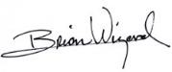

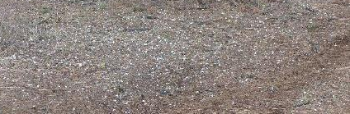
Looking through the side rearview mirror, we see the lineup: the hood attached to the trailer hitch using a cable, the tire, and a piece of wood to be loaded up and ready to slide.
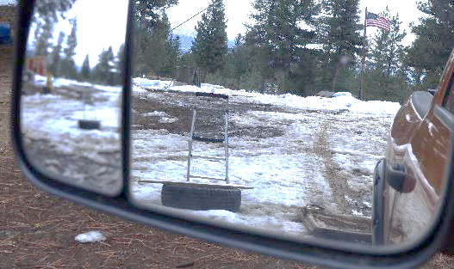
These are what I hate making in the mud: footprints and ruts.
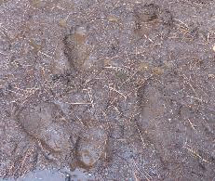
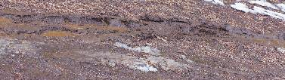
Work in motion, moving the tire on the hood sled.
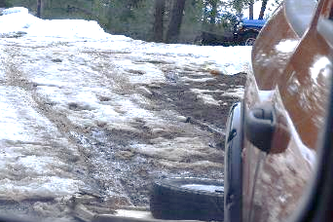
It won't take much cleaning to prepare this deck for a hot summer day’s lunch in the shade. The mushrooms will be refurbished.
Join the fun.
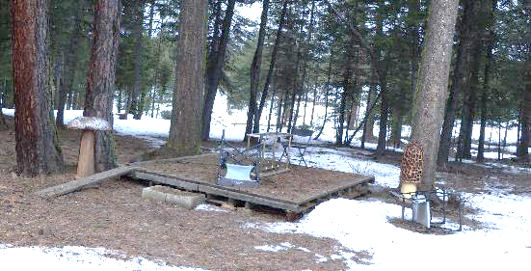
I put the tire in its new location with the other tires.
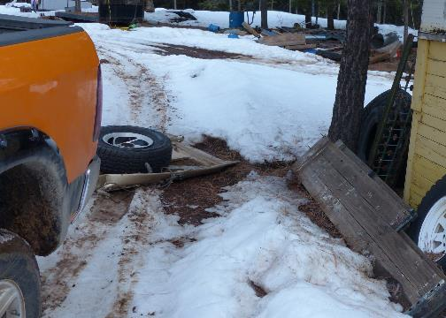
It can sit right there until I need to move it. Is the rim damaged beyond use? Maybe, maybe not. I only saw a small notch in it.
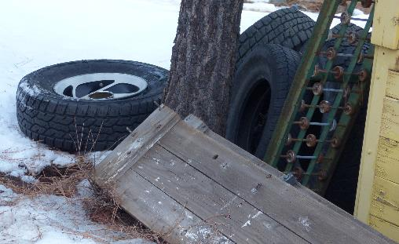
The ground is a minefield. This hole was camouflaged with ice.
No one wants to step into that ankle-deep cold wetness.
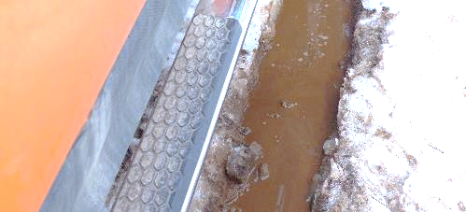
The hood has a resting place until it is needed again. It’s so nice not to lift the heavy logs when they can be rolled onto the sled.
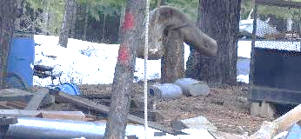
Do you see the new serpent head in the background, behind the inventory of spare lumber? I will trim it with the chainsaw and then make the ornate skin and head details using pieces of shaped wood attached to the body. I’ll drape fiberglass sheets over them for the fine details. This applique technique for detail will replace the more challenging chainsaw carving.
I have choices: pull in the other two parts, middle and tail, and make them look connected to the head underground, as is Bazil, or tack it to the outside of a building wall, and make it look as if it is bursting through the wall to escape.
Let’s see the snowy conditions on the road. The ice and snow are dwindling nicely on the plowed driveway by the gate.
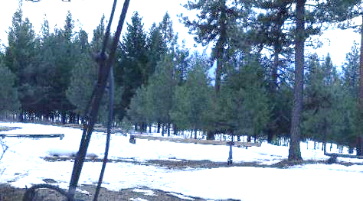
Here, two things are happening: first, the plow skims across the hard-packed snow, and second, occasionally, it digs in. When it connects with the ice sheet, the ice might break, or the truck might be stopped.
Skimming.
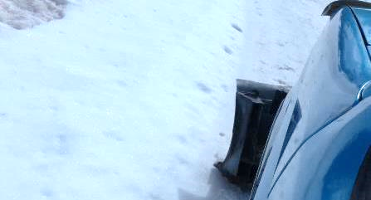
Stopped in its tracks. As the dirt reveals itself, there is a mud puddle there.
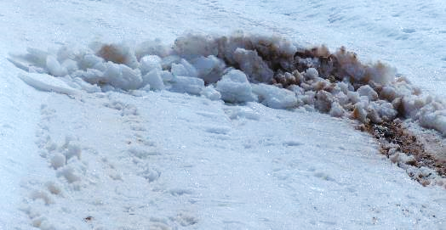
See the dip in the road? With the thick sheet of ice below that snow, I foresee a trap and would consider myself foolish if I fell into it, as I did last year. There are two more snow trapping areas in the driveway.
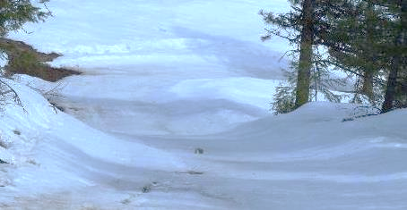
Here comes the next layer of snow, ½-1 inch worth. That is supposed to happen daily until next Thursday. There is no need to rush into any of this work. Spring is coming in a week, so says the calendar. Some people believe that the first day of March is the beginning of spring, but they are wrong. They judge this on calendar numbers, not astronomical facts.
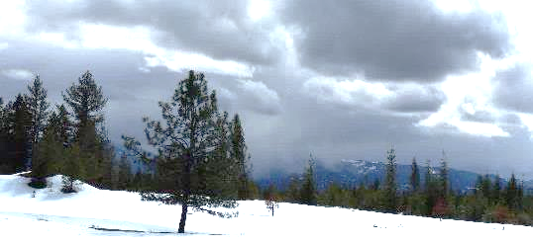
Therefore, I get to roll with the lack of punches and do more writing, thinking, and introspective growth. I’m learning more about the condition of my body because it is always with me, and I’m lacking distractions. My posture, gait, and vision contribute to my involuntary running to the next face-plant. I don’t like the feeling. It’s a very unsafe, insecure feeling.
I might ask the VA for support in a private physical therapy clinic. We all know I’m not volunteering to be escorted around like a criminal through a VA facility, and as far as I know, no such clinics are close.
Regarding the astronomical dance of a Lunar Eclipse happening tonight, I could shoot the Moon’s rise.
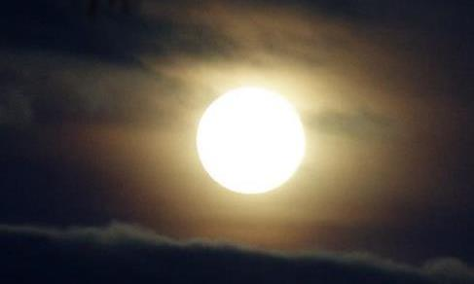

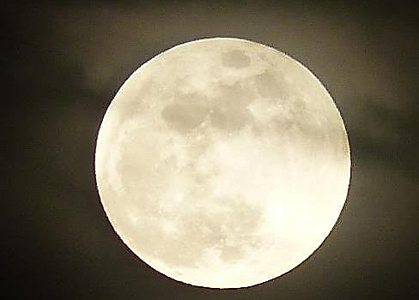
Clouds rolled in, and the eclipse was not available to enjoy. Upon rising for the day, I found it preparing to set. I approached it as if I had chopsticks to pluck it out of the sky.
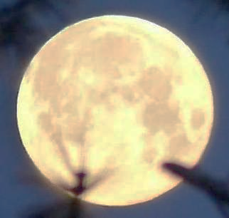
Another today arrived, and the weather report was:

Snow likely. Mostly cloudy. High near 39, with temperatures falling to around 37 in the afternoon. West wind 6 to 12 mph, with gusts as high as 18 mph. The chance of precipitation is 70%. New snow accumulation of less than half an inch is possible.

Right now, the sun shines under the above conditions, but I am not interested in the 6-12 MPH wind with 18 MPH gusts. The chill factor will lower those 37 degrees. I’ll sit next to the heater and jot down some psychobabble. I’m good at it.
I like the search to understand my Gawd. I am searching for my upcoming, newly designed self. I’ll be signing emails with the moniker Brian, the Olde.
I am having fun letting talents and traits fall by the wayside. I’m resting up for whatever comes next. I'm hoping for lots of good hard work and exercise with the chainsaw. There’s a mess of logging debris to clean up and leftover logs to move into places where the logging machinery made paths. Paths encourage the hoons to explore for a shortcut around my property from Lookout Road to Whiskey Creek Road.
I am performing an experiment that will eliminate visual vertigo. I have a lovely black leather eye patch that is pirate-worthy. Reducing my vision to one eye may reduce the conflict of sensory perception caused by two eyes not quite having their focus in sync, which could avoid vertigo. This out-of-sync focus would be caused by blunt force trauma. If one eye must adjust to match the other eye’s focal length, why wouldn’t I get dizzy? It’s almost like being in two places at once and trying to focus on one or being drunk and not seeing and thinking straight. As if caught in a spiral, a whirlpool, or even a dust devil.
There can be damage done to the retina by blunt force trauma. Retinal detachment. That’s what the eye doctor told me. I had one detached after that Owyhee landslide head-smashing incident. Looking it up on the web, I found:

Retinal detachment typically occurs when blunt trauma pulls the retina away from its normal position. … In conclusion, shockwaves and negative pressure contribute to retinal detachment. Shockwave propagation in the retina leads to a retinal break, while negative pressure and relative inertial motion could pull the retina away from the supporting tissue.
Copyright © 2013 Elsevier Ltd. All rights reserved.
PubMed Disclaimer

The eye doctor told me the best treatment was to let time heal the detachment since it was not extreme. This was a good call, as time did just that. But did the two retinas sync in focus?
When I look at a period at the end of a sentence, I see two. One on top of the other. When I close my right eye, I only see one. This tells me that the two lens are not focusing in sync.
Yesterday afternoon and into the night, this happened: a snow-spangled banner. Up to a foot more will arrive over the next few days. How Spring does tease Winter to leave, and Winter teases Spring with refusal.
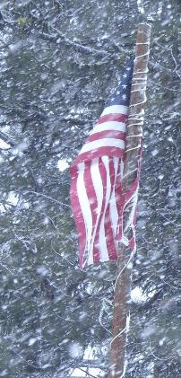
Throw some morels into a stir fry or soup, or soak your dirty, stinking socks in either; the aroma and taste will be about the same. That could just be me.
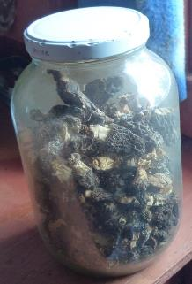
All the turkeys found their roosts for the night, and the weather got no better. They don’t care. Their talons tightly clench the branch they are on when relaxed, and they tuck their heads under their wings to sleep.
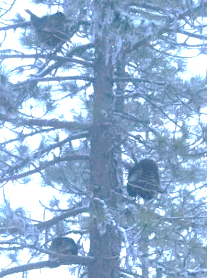
I climbed into my big, thick, warm sleeping bag and slept. We are in sleep sync.
The weekend is over, as is the latest Full Moon. Due to clouds, I couldn’t photo-track it until this morning.
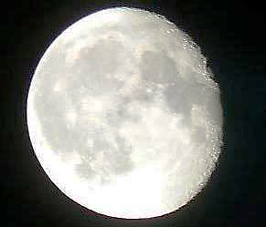
For the rest of this Moon Cycle and into the next, I will work on the illustrated music video for "Hitchhiking Man," which is on the Sings for His Supper CD and Minding My Own Business Folk Rock Opera. It’s on my website:
https://bwizard.art/bw_videos/minding-my-own-business-as-per-usual/
I’ll have RRC in Venezuela do the artwork. He’s slow but steady.
Here’s an update: I have written and sent RRC the first verse to work with. He hasn't responded in over two weeks. He’s always a bit sickly, so maybe he cannot play the part of a focused illustrator.
This is an example of what I’ll give to RRC so he can replicate this scene in a sketch. I’ll have him change the background to something more roadworthy.
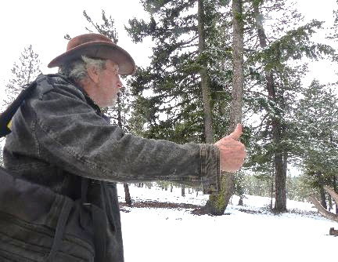
To demonstrate how dull these days are, I’ll show you a chore I must do every third day: Water Detail.
This is brand-new, freshly fallen snow. It's pure water, besides all microplastics, radioactivity, and nondescript chemicals. I filter it through two carbon filters. If it kills me in 15 years, I’ll call it right on time.
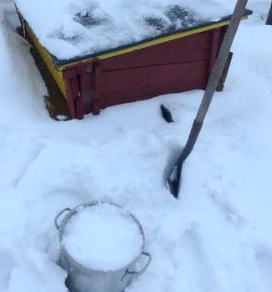
I shovel some scoops into the three big pans, pack them down, and put them by the fire.
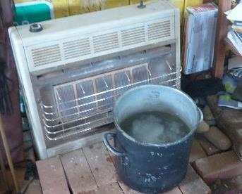
I use it to do the dishes or take a sponge bath.
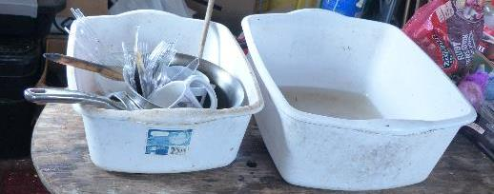
At this point in the sequester, the timeline appears to have changed. It’s all the same day. The day after my demise, I might be asked, “So, how was your last life?” My answer might be the same as the last time I was asked: “One long day, man.”
The good news is that the Spring Equinox is approaching, and the days and nights are almost equal in duration.

Sunrise: 6:53 AM
Sunset: 6:59 PM
Daylight Hours
Today: 12:06
Yesterday: 12:04

I don’t need to monitor the turkeys’ need for some treats. One or more will stand at my door or window, peering in like a Peeping Tom. There’s no privacy within this forest.
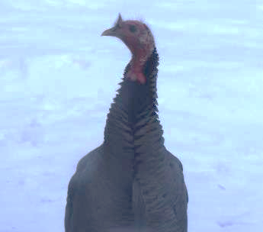
This is the filtered water routine I’ve been performing on the regular.
Once the snow is water and the time comes to run it through the filter, I strain it through a screen to remove the tree needles, bark, and lichen, then pour it into the top of the two-part filter.
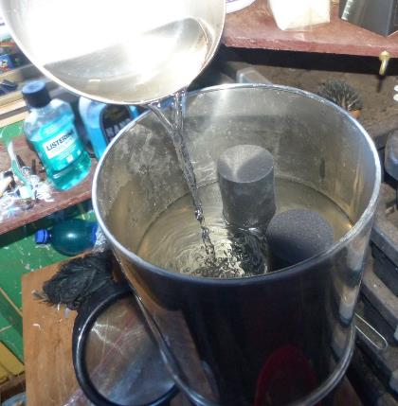
It’s the first flyby of the season/year. I think it is the logging company or the state predator-hunter looking for wolves, cougars, and coyotes to eliminate for the benefit of the sheep herder.
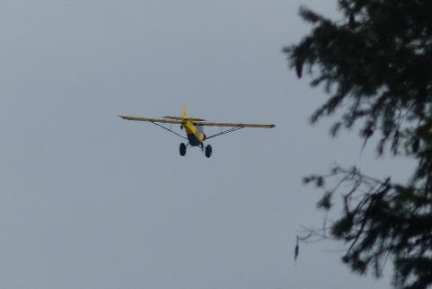
Spring weather will start soon, with predictions of mid-sixties temperatures within a week. That will melt both snow and ice. Busting out will lift my spirits, as a sense of loss and depression have surfaced ten weeks into the sequester. It’s normal behavior, as will be my elation of freedom from self-imposed imprisonment.
It will be good until I run into the public. My spring emergence is when the locals have a chance to slam me with some degrading comments: “They let you out, or did you escape? Oh no, trouble is back. I thought you died or should have.”
Never initiate a game of wits against a master. You can’t win.
Speaking of contestants, I think I have a short enough letter to send to the VA. I’ll soon see. It’s brief because it is my first volley of wit-bombs to be sent into their camp.
Ten weeks into the sequester, and things are at a lull. There’s no actions beyond my control for me to counter. There is no challenge, no fight. All is working just fine. Ho hum.
What to do in a transitional lull? The outside air is wet, cold, and it is no fun to be in at all, so I stay inside. I’ll have eight months of outside weather soon enough. In the heat, I don’t work outside, either. I can choose when to do the heavy work outside: morning or evening, as summer days are much longer than winters. In the heat of the day, I melt into a horizontal position in the shade.
It is Sunday, March 23, 2025. The month and the Moon are ending. They will bring a change, and I will appreciate the rest. This Moon brought on a big lull. I’m not a great fan of lulls, as I’d prefer to be active with a goal. My goal now is to survive this sequester. I consider this training for what’s coming, the lulls of old age. Old people, especially those being babysat inside old folks’ homes, have scheduled lulls that would drive me up the wall. The organizer brings them games to play in the community room. The games children would play. How disrespectful is that? Very.
The game I play is getting through this self-imposed prison sentence, spiritual retreat, or life-planning self-exploration challenge. What could get in the way of that?
A developing health issue could. I was asked by a townie what I would do if I got sick. I told him, “I have options. Recover or die.”
I have a problem that could turn lethal. I have developed a lesion of the kind I’ve never seen before. It’s in a safe place I hardly ever visit. I’ll withhold the details as the problem is in the genital area. Why? Remember when the tire on the snowplow truck was pushed off its wheel by a hidden, beneath-the-snow broken treetop? The excitement of the incident made the fast-moving intestinal tract soup race to the exit. I had to disembark the truck, remove gloves and jacket, drop trou, bend over, and push. This forced the sickly soup that didn’t digest well out with force, which was a good thing. The shotgun-like spray was not a pretty sight.
I could find only one square foot of non-absorbent cloth in the truck’s cab to take with me for cleanup. That wasn’t enough. I spent an hour trying to unleash the spare tire mounted underneath the flatbed and failed. I had to walk home uphill. The chore of fixing the tire situation was shut down due to the approaching sunset. It was hours past the intestinal purge, and that was too long. All the walking and work ground the nasty residue into the skin by the elastic hem of the tightie-whitie undies. Who knew that was a hazard? Babies and moms.
I finally got home, turned up the heat, got naked, and had what I thought was a thorough sponge bath. It wasn’t. Bacteria that were ground into the folds of the skin created diaper rash. This infection did not bother me for a week or so, yet it was fermenting within, and soon, it would cause itching and pain and open rash. Not knowing what it was and finding it very hard to see the problem due to its location down under, I could only guess the type of malady that had developed.
My guess was a diaper rash-type infection, a fungus infection, yeast, or some rare form of STD without the S. Here’s where the isolation comes into play: What to do about it? Treat it with any or all the OTC ointments, salves, or powder I had at hand. Of course, I looked up all the possibilities via the Internet. My guesses were as close to a professional’s guess as possible.
I had to turn to my own choice of OTC medicines: antibiotic salves, antifungal salves, and hydrogen peroxide. I have eaten Golden Seal in caps. It does well as an herb for blood cleansing. I finally found a position I could put myself in to see the infected area: using a mirror. It was not a pretty sight. So ugly, swollen, and red, I worried about blood poisoning. “Finally killed by Sepsis” is not an epitaph I want on my imaginary gravestone. Hence, I have been applying all the salves since. I don’t see much improvement, but I’m colorblind, so the red may have changed to not-so-red. The itch and pain have significantly diminished, so I think I’m on the road to self-healing. I’ll know I’m wrong if I get up and walk away without a leg or man parts.
Fever will tell me if the infection is winning. If that is the case, there is a race to the death. Wait! Death by such a natural cause is fair play. If the snow doesn’t let me escape, so what? Can you tell I’m pretty much done with this life? It doesn’t hold much for the future. Sure, there are things to do, but none of those things will matter if not done. Surviving a meager existence is not how I roll.
I have two goals on my bucket list: Dedicate my combat gear to the new Smithsonian Museum and walk this historic fire lookout into its second century. Then I will be done and ready to go, Go, GO!
This open road is a good sign that the sequester will end soon.
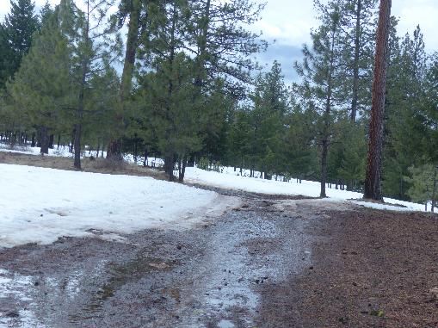
Of course, not all driveway areas have had so much sun.
I am not ready to venture down this hill until the predicted warm air rolls through over the next two days. I would like to see a spot of ground on the water bar’s upward edge and top.
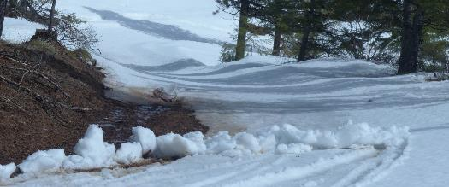
It is right before that last shadow that I was stuck in the previous year. On the left side is soft mud, which snagged me and stopped me short.
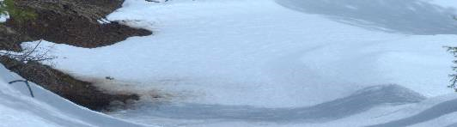
The ridgetop needs a minor cleanup; push away the drifts.
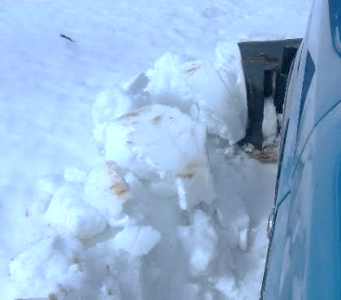
Exposed are chunks of the sheet of ice that I have been avoiding.
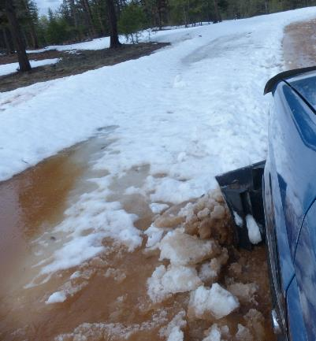
This is as far as I could get before the ice froze to the ground stopped me.
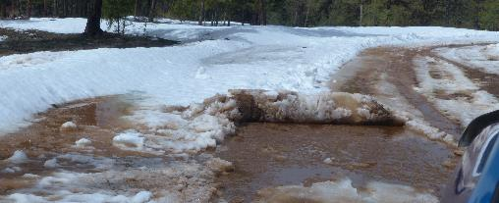
When the sides open, I can put channels in the dirt to drain the water.
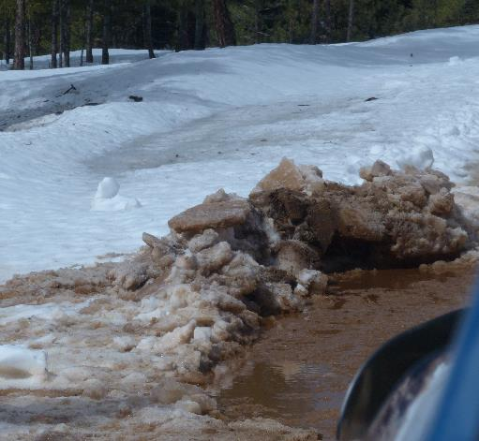
I might install the new battery in the Tahoe and use it to run me through the forest on work details. There are no worries about scrape marks, dents, etc.
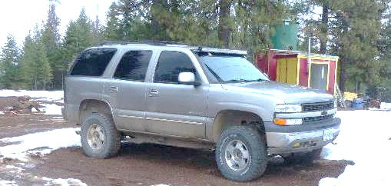
The pond water has several feet to go before it overflows. Runoff and rainfall might do the trick.
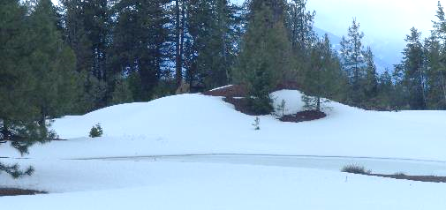
I thought about making a mad dash down the hill, but this snow told me I’d regret it.
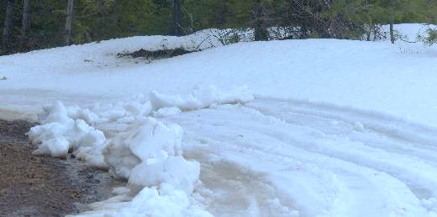
The nasty sheet of ice is on display in this photo.
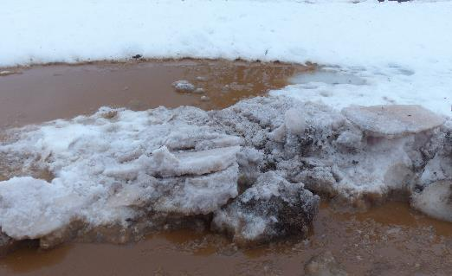
Under that snow, I will find an old drag sled hood and the twenty-five feet of cable I wanted to use to help free the snowplow truck when it was stuck. We’ll see.
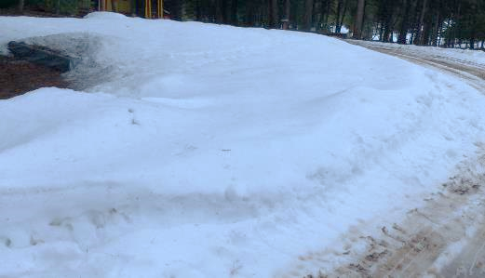
Yes, ruts are Spring’s bane.
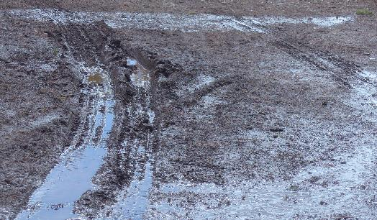
Two days of high fifties and low sixties. That should make a difference. If I escape on April 5^{th,} the sequester will have lasted for 80 days.
Shopping to replenish food and water stocks will be a goal. Next year, I will eat more fruit and fewer cookies.
Where does this leave me? I think it is time for another chit-chat with the Gawd entity. See if we can arrange a mutually beneficial exit.
These two fellas deserve a shout-out. They don’t appear to care about procreation. I’ll be keeping an eye on them to see if they boink any hens.
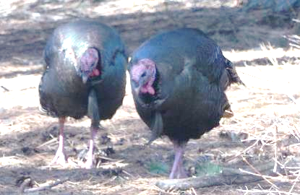
The does were boinked by the one big buck, maybe some smaller ones too.
I will have a batch of newborn smiles and personalities with which to communicate come June.
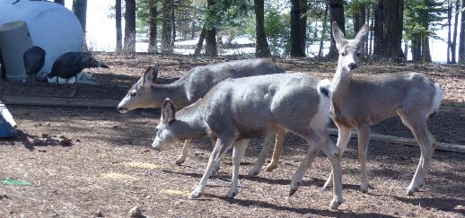
These little procreators fill out their numbers frequently. Of course, they are the most fed upon creatures, excluding bugs.

That’s all good. It was springtime fun and anticipation but today felt like the day to bust a hole into the great wide open. Cautiously, of course.
The ridgetop is very passable.
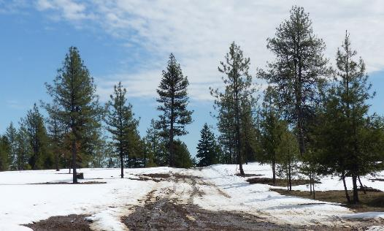
Daily trips will once again provide a view of the Seven Devils.
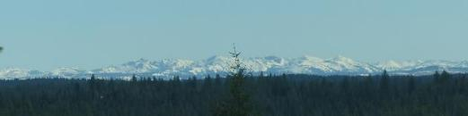
At the bottom of that dip is where I got stuck last year. It doesn’t look treacherous. “I’m going in.”
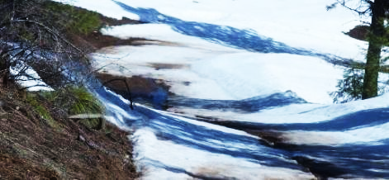
That post-COVID myalgia did a number on me. I’ve been teaching myself how to walk correctly and comfortably. One exercise will be to teach myself how to run without ending in a face-plant. Keeping an upright frame will help.
My patience again paid off as the once-frozen snow mass was soft and pliable.
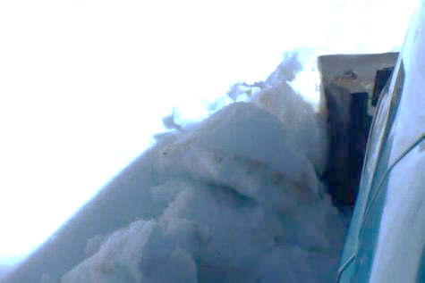
The world awaits me down that road. It looks passable from here.
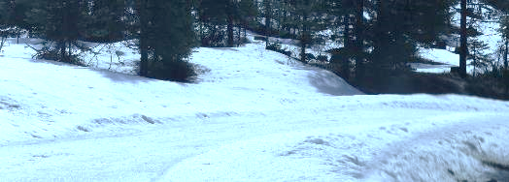
Spring has sprung, and the creeks do run.
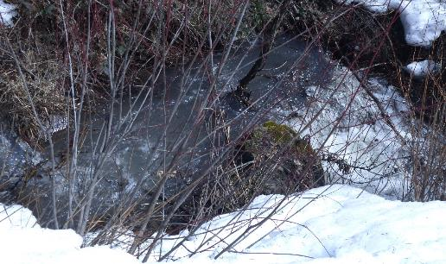
Oh no, hoons were in the neighborhood. The Road Closed sign is behind that target wood.
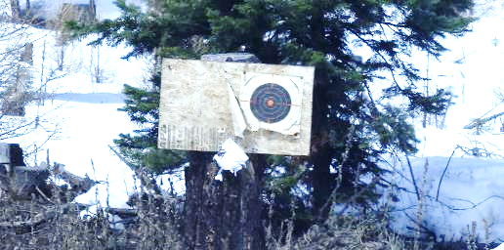
Of all the trees that did not hold someone else’s property, the hoons decided to use and destroy someone else’s property. That is why they are called ‘hoons.’ Auz and Brit slang for hoodlums.
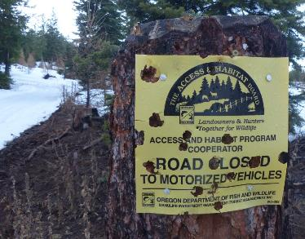
I had to hit this frozen snowpack five times, moving it a few feet each time, before it was no longer a barrier.
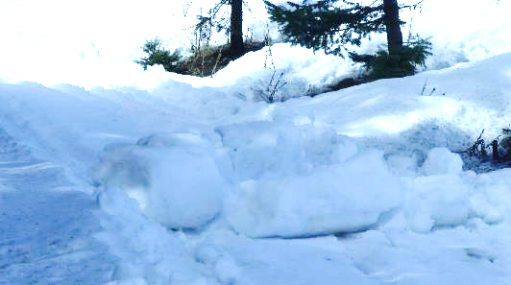
The BIG NEWS is that I was correct. Patience has been the answer to several work issues. “Work or wait?” Waiting helped me get the snowplow unstuck, and I drove away. Today, we see how not rushing into this challenge allowed me to escape any more getting-stuck-in-the-snow stories.
I put metal shoes on the front of the plow to keep the blade from digging into the dirt. If the dirt has been lifted, as it does when ruts are made, the blade can catch it. The truck stops soon after. It’s good to do, though, as the mud is pushed to the side and out of the way.
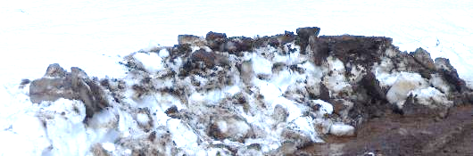
Can anyone spell “Cleanup?” Yes, all the snow-covered trash the wind and I tossed around over the past few months is now exposed. I have one of those spring-loaded pickup devices. I’ll be out there by nine, picking stuff up. Nine on what day is still undecided.
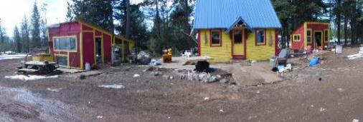
Here is the view I’ve been patiently waiting to achieve.
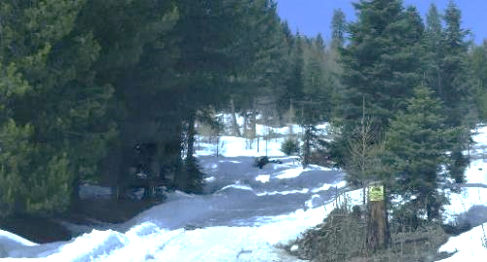
The driveway road is open. Come visit.
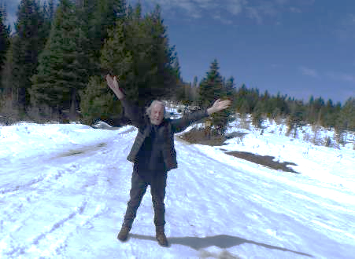
It’s the little things that give me an incredible feeling of success. Before this sequester concludes, I have two things to do: One More Chat with Gawd and a quick party to express my appreciation for your reading time.
These two boys like a noon-time nap somewhere on this mountaintop. A flat spot, for sure.
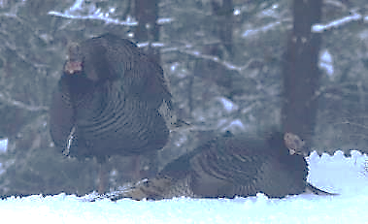
I’m not going anywhere under this lack of visibility.
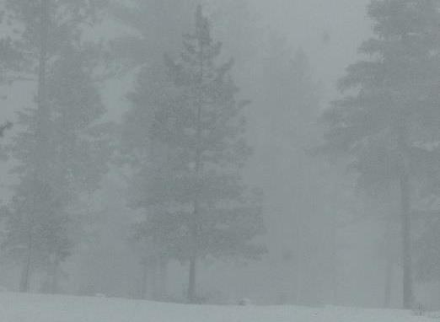
Especially up. The steps are ice and snow covered.
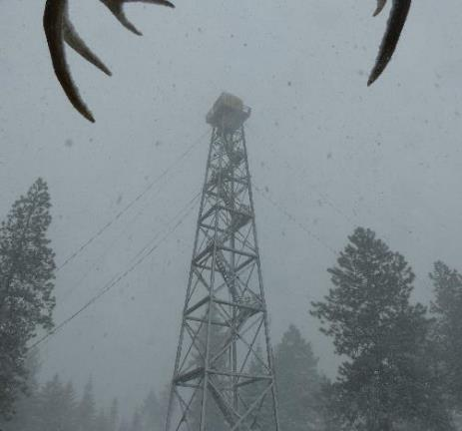
That is not an expression I want to wear, so I’ll go inside.
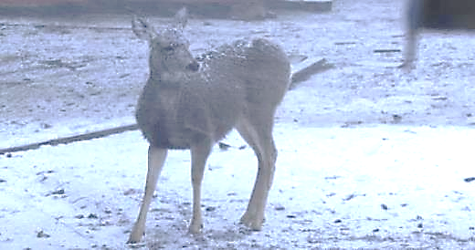
I will have fresh runoff water to draw from at the Lazy Frog Pond, where the water table is full and overflowing.
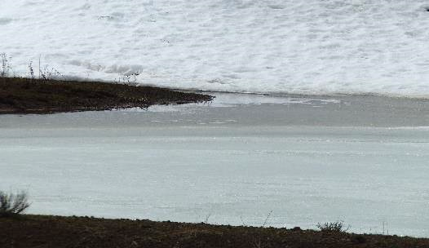
In the end, small runoff streams lead to bigger ones, flowing to the rivers and ocean. I like the system. My estate is the headwater of Dry Creek. Yes, not much water, but a creek’s worth in the spring.
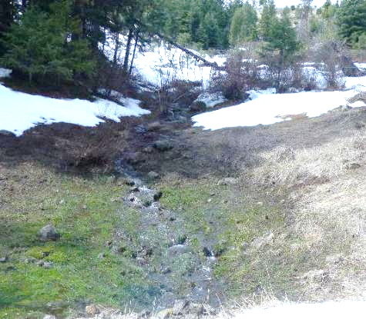

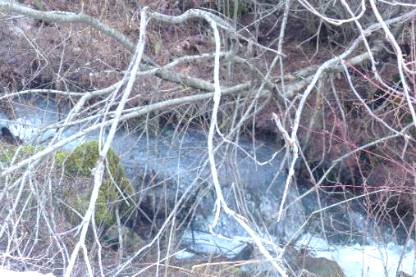

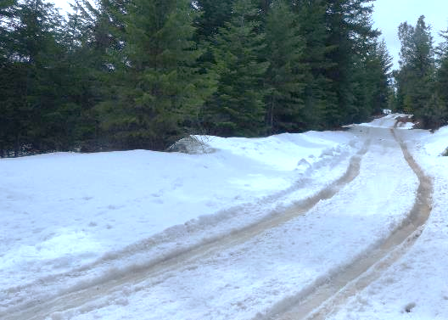
I had fun going on a treasure hunt. Do you recall me saying I threw things under the truck's rear tire so it would climb out of the hole it dug when spinning? V-bar chains are equal to the teeth of a chainsaw; they cut in.
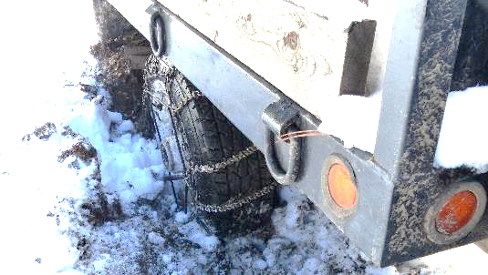
One of the items that went in was a small-linked chain. It was buried under the mud, which froze and was covered by snow. Two days ago, I noticed the snow and freeze were history. I took a pick and went on a treasure hunt for the chain. I knew where it would be.
The dark dirt is what the tire chains churned up.
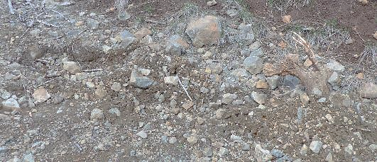
On closer inspection, I found my quarry. Yep, buried.
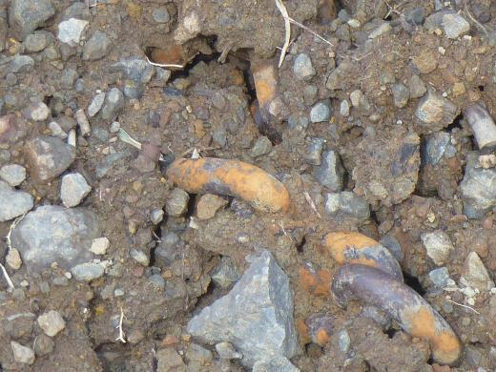
I just saved money by not having to buy another chain.
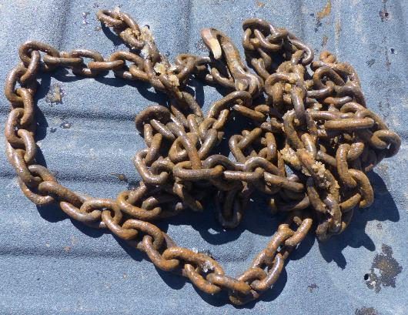
Well, well, well, it must be spring. The Red Diggers abound from the ground, and merriment is being had by all.
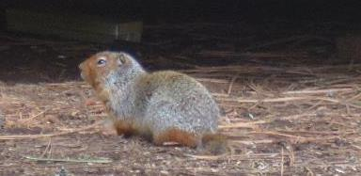
Look at how I almost tipped this big rock into the creek.
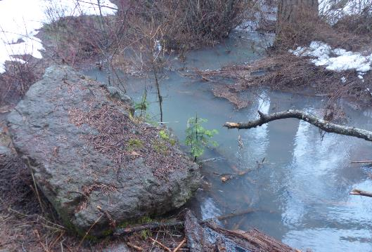
I would have been a fast-moving floater if I had inadvertently slipped. NOT!
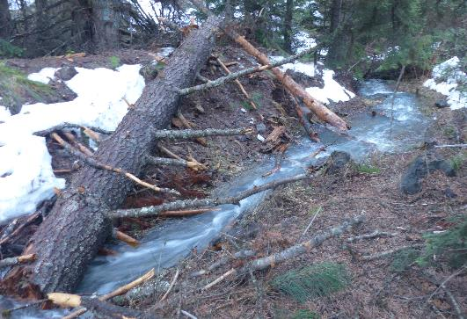
Roadkill or predator kill. It was truly picked bare by carrion scavengers.
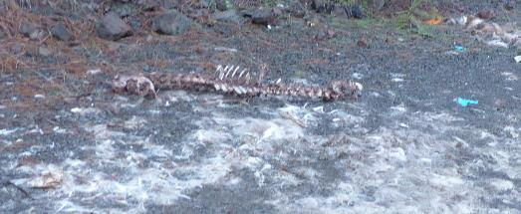
My money is on removal by predator. Why?
This is my end game, to become a predator’s turd and then become the forest. I want to become a predator’s turd like this wolf turd I found right where the truck was stuck the first time and not far from the carcass.
Rabbit haired turd.
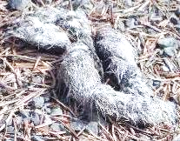
In town, the question will be asked, “Whatever happened to that eccentric combat veteran who owned the Tope Creek Fire Lookout?”
“He’s still there. He became the forest around the fire lookout.”
“How?”
“The carnivores of fur and feathers stripped his bones clean and shit him out.”

One More Chitchat with Gawd

I thought I’d take another walk around the property to see how the meltdown was going. Well, I first noticed the rubbish on the ground, blown around by the wind or tossed away by me. After this walk, I grabbed the easy picker-upper and put most of the trash in a bag.
I didn’t feel a tap on my shoulder, but I could feel the presence of the Supreme Consciousness. “What’s up?” I initiated.
“I’m checking in to see how your isolation is going. I see you broke a hole through the snow and are now free to roam.”
“Yes, all that freedom and no place to go.”
“Have you worked through your list of things to accomplish?” It asked.
“Let’s review.” I made air quotes with my fingers when repeating the list.

1: Track the developments throughout this sequester and self-help game in this diary.

I do like to write. I probably rambled on too much for anyone but me to find the story interesting. I reckon it’s a fair journal, with photos.

2: Make it all fun.

I did have fun, and I’m still having fun. The jar of herbs helped keep it all fun and relaxed. Being alone meant I had no arguments, was never late, was never too stinky, nor bothered nobody save the email recipients.

3: Go deep and reward myself with revelations on becoming a better me in the future.

We’ll see about that. I have some ideas. I do not believe my being as flippant, gregarious, or effusive as I am a problem. Not for me. I have the right to do all of that. The new people, the young people, don’t understand how I can do and say as I please. They don’t appear to understand the Bill of Rights, especially our freedoms. This is due to a lack of teaching.
This will be a work in progress.

4: How to act in public has yet to be tested.

Quiet and invisible might be the new public strategy. I have my doubts that it can happen.

Focus on button production.
I did that quite successfully. I proved to myself, “I’ve still got the knack.” I also proved that button-making is not how I want to spend my days.

Music.

I had three guitars, four flutes, three ukuleles, a bag of harmonicas, and my homemade Humming Blade and Bona-Chimes. I wanted to make music, and I did, inside my head. I realized that since I don’t play much in public and my videos don’t go over well, I would gain a lot of free time, headspace, etc., if I quit pretending to be a musical performer. So, we’ll see how that goes. I’m not taking requests, sorry.
By the end of the sequester me and RRC did manage to create the Hitchhiking Man illustrated music video. Check it out on my new website: bwizard.art. You’ll have to scroll down a fit to find it.

Snow manipulations.

I did what I could. I stuck the truck three times. After the last time in the yard, I let it stay stuck until the ice and snow holding it in place melted. I exercised patience instead of working hard to break a hole in the ice and snow, and with your Divine Intervention, the truck was freed.
This also gave me a great excuse not to plow. I would venture a guess that I saved a tank or two of gas by not plowing. $125 each.

Survive.

I did well with this challenge.
This winter sequester was slow, easy, fun, suspenseful, productive, thoughtful, and life changing.
I am relieved to leave behind old habits and disciplines. I’m sure there will be a compromise as I put these thoughts into practice. I have some artwork I want to finish instead of tossing it away.
“Is there anything you want to talk about?” I asked my Gawd.
“Would you like to hear about your future?”
“Maybe, maybe not. I like the details of the surprises as they unfold and reveal themselves to me. I will ask, ‘Is my demise coming soon?’”
“I don’t see it. That could mean it will be a surprise accident. I’ll save you if I can.”
“It’s good to have you on my side but let it be if the accident provides a glorious end. Whenever you want to talk, just step into my head.”
With that conversation out of the way, I entered my cabin, sat in my chair, and lit the bong to keep the fun rolling.”
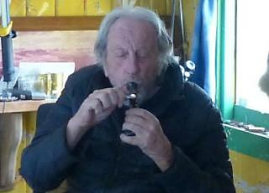

At this point in the sequester, I will have been in this seasonal transition for 80 to 85 days. Spring will be in the air soon, and I have nothing but hard physical labor and naps to perform until next winter arrives.
With the sequester story done, my slate will only hold future projects.
On my last trip to town, or the first one lately, I had to go to the Chiropractor and take care of some unfinished business. The guy let me hang a photo printed on metal in his office. I told him that if anyone showed interest in it, he could sell it for $250. He laughed.
“It’s autographed to make it a collectible heirloom,” I pushed.
Last year, he chose to throw away his Brian Wizard Privileges by being rude and insulting. Well, that’s not right. Hence, I removed this photo from his office and my name from his list of clients.
This is the first sunrise of 2021, coming up from behind the Seven Devils Mountain Range in Idaho. It was photographed from the highest cabin in the sky in this neighborhood.
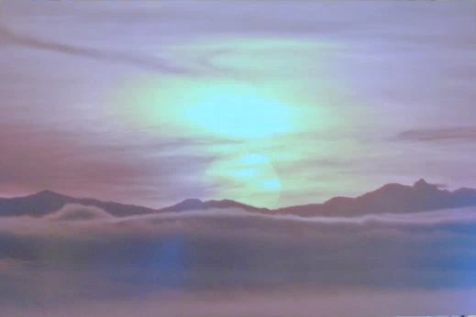
Remember me saying, “I like to walk out my door in the morning and greet the turkeys and deer with a cheery salutation and chitchat?” Attached is an example of what I’m talking about.

https://www.vimeo.com/1071946582

This little fella wants me to toss some sunflower seeds.
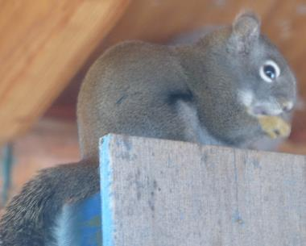
This isolation project started at the beginning of the waning Moon’s third quarter. Now, it ends during this Moon’s second to third quarter transition.
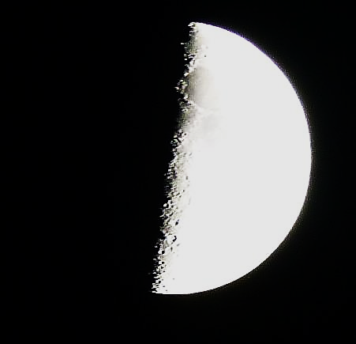
I see no significance in this. It was a well-played set of Luna Cycles. Oh yea, that means I’m older.
I must mention that I have decided how to live my work life as Brian the Olde. Lightly, as I did with the buttons. Fifty-nine was enough to answer this question: Could I make such buttons? If I suddenly received a large order for copper, silver, or coin buttons from anywhere, would I sit and make them? Would I bother to hire and train others to do the work? I think not.
No more serious music playing or singing. I did my best with the four illustrated music videos from within the Life Immaculate story. Sorry, that’s all you get for now. I could be wrong. I have already produced a cornucopia of songs, many recorded in the Minding My Own Business folk rock opera. That would be an excellent project to finish. Thirteen illustrated music videos as an opera. The entire FRO would be a great accomplishment as part of my AI Theatrical and AI musical legacies.

EPILOGUE

The isolation is over, but the novella needs an epilogue, so I have gathered photos and stories. By the Full Moon, I should be ready for the next phase of life: spring cleaning and setting up for the rest of the year.
As you can see, we are close to the fullness of our satellite. Does it look smaller now? Due to its distance from us, it is the furthest away from Earth in its orbit. We see the difference in the size of the moon, twenty-five percent smaller.
The third quarter begins in less than two days. This second quarter has been full of fun, rebirth, and new things to replace the old.
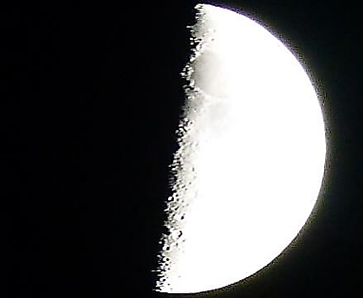
You know the definition of “GONG!” Out with the old, in with the new.
I stepped outside the other morning and said, “Let the fun begin.” Looking to my left, I saw that it already had. The Fuckening Season is in full swing.
When the hen’s tail lifts, Tom goes for the money shot. You can hear the connection if you are close enough, as I was. Boink, or even Spluck.
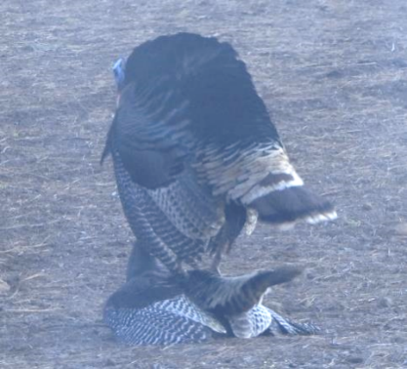
Soon enough, Tom is back to the vital part of life.
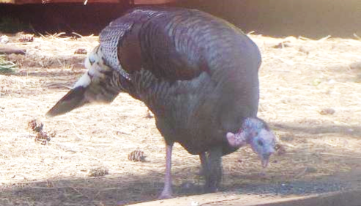
It’s Stump the Chipmunk with the short tail. This fella is getting old.
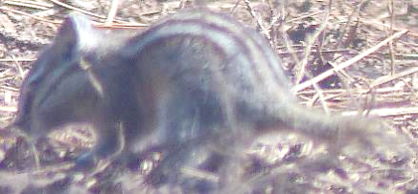
There were some cocktail hours with me drinking water. BORING! No big crowds, just the inside perimeter chippers.
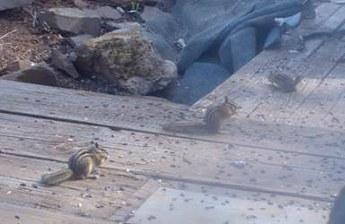
And a few red diggers.
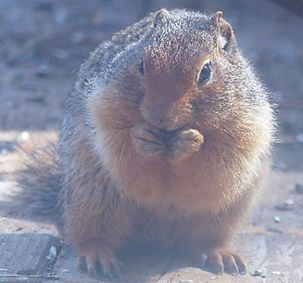
Why did the ducks get arrested? They were dealing quack.
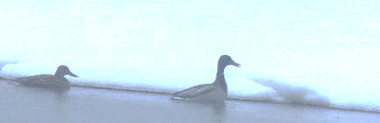
That joke was told by the young man Trump invited to his meeting with Congress. The boy that no Democrat would stand up and applaud for beating cancer.
Whiskey Creek Road is opening for the turkey hunter traffic.
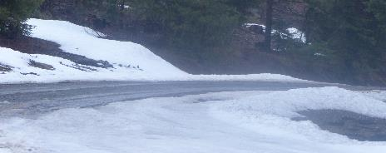
I chose to go to the right. Down that way is where the healing from too much isolation awaits.
The owl from last year chose this nest, which was used by red-tailed hawks last year.
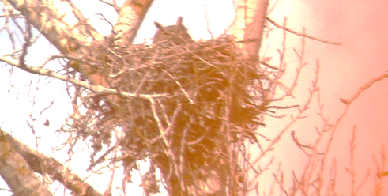
What’s that noise? “GONG!” Yep, out with the old (the truck, not the guy).
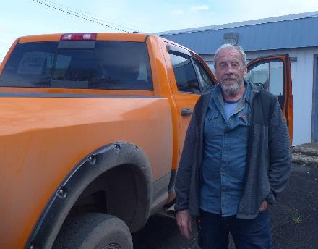
In with the new.
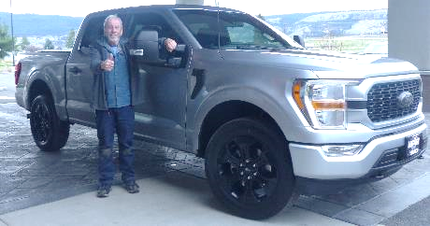
See, I told you so. “GONG!” Out with orange, in with the silver.
I rented a room to celebrate in a new hotel in The Big: the Hampton Inn. I was dehydrated and sleep deprived. I didn’t think nighttime was the time to challenge the curves of the road down the Minam Grade, and then up my mountain, and through all the suicidal wildlings.
I did indeed enjoy some hydrotherapy. It healed me big time. Of course, what else can you expect from a place called The Big? A big purchase, a big healing, big food, and a big haircut.
The TV welcomed me.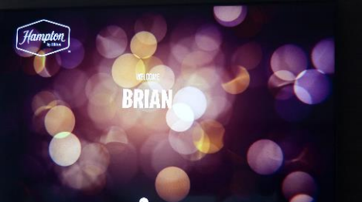
Only 40435 miles on the new-used Ford 150. Better than the Dodge’s 80K.
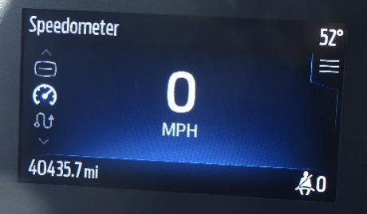
It is “in” with a cane and out with some of the insecurity of walking and feeling dizzy and off balance much of the time. I was surprised at the security the third leg gave me. Having a third leg touching the ground soothes the worried mind. TBI from last July’s face-plant has kept the vertigo right below the surface of my balance.
I was standing in place to throw out food for the wildlings, and for no reason beyond vertigo, my head spun to the right with torque. I spun to the ground in a controlled drop to find a square rock’s four-inch protruding corner with my right butt cheek. I had me a controlled ass-plant that made me lame for three days due to a bruised muscle.
My friend Doug uses a cane just like the one I bought. He’s six weeks older than me, so he must know what’s good or not. I tried it. I liked the security of having a third connection point with Earth. I figure, with some practice and a choice of matching clothes, we might do a soft shoe routine. The trick will be not to fall over.
I haven’t fully used the cane yet. This purchase was made before the hydrotherapy. The next day, my body was in the best condition since July. The vertigo slipped further into the background. I have felt no need for a cane. Of course, that’s how it works. I’ll use the concealed gun adage, “Better to have it and not need it than to need it and not have it.”
I have a new haircut, truck, and cane, which gives me a new lease on body balance and, as you read, a new me ready for this next phase of life. Brian the Olde. The redefined me.
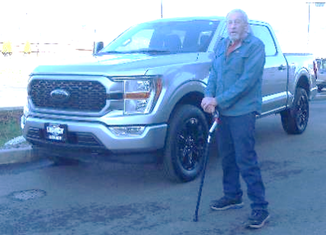
This break from isolation was exactly what I needed. Cabin fever was dispersed. I saw how being amongst people is highly overrated. It’s hard for me to keep a straight face. They appear to be quite bent mentally, socially, and all around. Somewhat empty in thought and actions that are not of their own making. It is as if they are following a program they were told to follow.
The news explained to me that children today are taught what to think via their addiction to social media and not taught how to think. No wonder I don’t fit in. I have a certified disability to be the way I am, and I am self-taught on how and why to think on my own. What’s their excuse? Incompetent schooling.
I returned home to find the pond full and my tower standing tall.
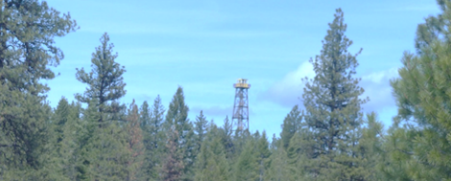
When the morning temperatures stay above freezing, I will start hauling water for the elevated tank to give me back the kitchen and shower water. I hope Darin will arrive with a new batch of young female firefighters for training and to fill the 3500-gallon firefighting water tank.
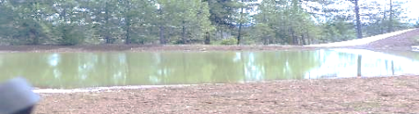
It’s good to be back home with a clear head, resupplied, and ready for the subsequent seasons of life.
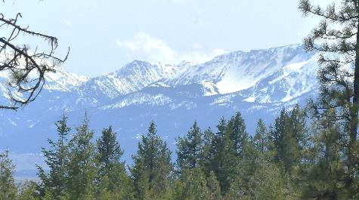
There’s just enough time to make serious cleanup progress before the New Moon in two weeks. So, if you need me, come visit and bring yard tools and gloves.
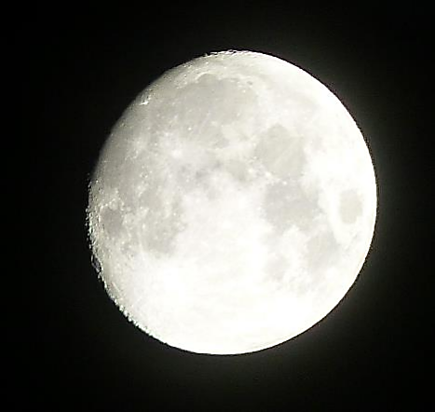
The novella’s release is delayed due to the need for an epilogue. This photo letter will be a part of it, if not it. Otherwise, continue having fun your way, and be willing to share some of it with me in writings with photos.
Cheers,
